**Study Notion Portal**

**Full-Stack Web-Application**

**Major project report submitted in partial fulfilment of the**

**requirement for the award of the degree of**

**BACHELOR OF TECHNOLOGY**

**IN**

**COMPUTER SCIENCE AND ENGINEERING**



Submitted by:

Manoj Kumar , (206301098)

Manibhushan Kumar , (206301095)

Ramchandra Nath Siddh , (206301012)

Aditya Rajendra Narnaware , (206301102)

Under the guidance of:

Mr. Deepak Painuli

Assistant professor

**DEPARTMENT OF COMPUTER SCIENCE & ENGINEERING**

**FACULTY OF ENGINEERING AND TECHNOLOGY**

**GURUKUL KANGRI UNIVERSITY**

**2023-2024**

**ACKNOWLEDGEMENT**

I would like to express my sincere gratitude to **Mr. Deepak Painuli**  for your invaluable guidance and support throughout the process of preparing this project work. Your expertise and insightful feedback have been instrumental in shaping the content and ensuring its quality. Your dedication to fostering a conducive learning environment and your commitment to excellence have been a constant source of inspiration. I am truly grateful for the time and effort you have invested in providing constructive criticism and encouraging me to strive for academic excellence.

I appreciate the opportunity to learn under your tutelage, and I am confident that the knowledge and skills acquired during this process will be invaluable in my academic and professional journey.

Name of students

Manoj Kumar

Manibhushan Kumar

Ramchandra Nath Siddh

Aditya Rajendra Narnaware

**ABSTRACT**

StudyNotion is a dynamic ed-tech platform designed to revolutionize online learning experiences. Built upon the MERN stack, StudyNotion offers a seamless blend of cutting-edge technologies to create, consume, and rate educational content. At its core, StudyNotion aims to bridge the gap between students and instructors, fostering a global community of learners. Through intuitive user interfaces and interactive features, students can engage with a diverse range of educational materials, making learning accessible and enjoyable. Meanwhile, instructors have a platform to showcase their expertise and connect with learners worldwide, enriching the educational landscape with diverse perspectives and insights.

The platform's architecture ensures scalability and reliability, with a robust back-end powered by NodeJS and MongoDB handling data management and processing. Security measures are implemented to safeguard user data and privacy, maintaining trust and integrity within the StudyNotion community. Through a carefully crafted API design, developers can seamlessly integrate StudyNotion's functionalities into their applications, expanding its reach and impact across different platforms and devices. Continuous deployment practices ensure rapid updates and enhancements, keeping the platform dynamic and responsive to user needs and technological advancements.

Looking ahead, StudyNotion envisions a future where education knows no boundaries. Potential enhancements include personalized learning experiences, real-time collaboration tools, and advanced analytics for insights-driven education. By prioritizing user feedback and market trends, StudyNotion remains committed to its mission of democratizing education, empowering learners and instructors to thrive in an ever-evolving digital landscape.

**CERTIFICATE**

This is to certify that the content of this Major project report are compiled and written by us and we have not copied them from anywhere. This work is done by us and we have not presented it anywhere else.

|  |  |  |  |
| --- | --- | --- | --- |
| Manoj Kumar  (206301098) | Manibhushan Kumar  (206301095) | Ramchandra Nath Siddh ,  (206301012) | Aditya Rajendra Narnaware  (206301102) |

**CERTIFICATE**

This is to certify that the project work embodied in this project file are done under my supervision and are not being copied from anywhere or presented anywhere for any sort of benefit.

**Mr. Deepak Painuli**

Assistant Professor

Department of Computer Science & Engineering

Faculty of Engineering and Technology

TABLE OF CONTENTS

**CHAPTER 1: INTRODUCTION**

1.1 Background of the Study

1.2 Problem Statement

1.3 Aim and Objectives

1.4 Research Questions

1.5 Scope of the Study

1.6 Significance of the Study

1.7 Structure of the Study

**CHAPTER 2: LITERATURE REVIEW**

2.1 Introduction

2.2 Recommender System

2.2.1 History of Recommender System

2.2.2 Application of Recommender System

2.2.3 Types of Recommender System

2.3 Challenges in recommender system

2.3.1 Sparsity

2.4 Comparison of Techniques

2.5 Discussion

2.6 Summary

**CHAPTER 3: RESEARCH METHODOLOGY**

3.1 Introduction

3.2 Methodology

3.2.1. Data Selection

3.2.2. Data Pre-Processing

3.2.3. Data Transformation

3.2.4. Modelling

3.2.5. Evaluation

3.3 Logical flow of the system

3.4 Item based collaborative filtering

3.4.1. Item-Similarity Computation

3.5 Rating Prediction Computation

3.6 Generating Recommendation

3.7 Tools

3.7.1 Python

3.7.2 Graph lab Create

3.7.3 Pandas

3.7.4 NLTK

**CHAPTER 4: IMPLEMENTATION**

4.1 Introduction

4.2 Dataset

4.2.1 Business

4.1.2 User

4.3 Exploratory Data Analysis

4.3.1 Business Dataset

4.4 Data cleaning

4.4.1 Business Dataset

4.5 Data Partitioning

4.6 Model Implementation

4.6.1 Data Staging

4.6.2 Model Building

4.6.5. Recommender System Interface

4.7 Summary

**CHAPTER 5: RESULTS AND EVALUATION**

5.1 Introduction

5.2 Model Output

5.3 Summary

**CHAPTER 6: CONCLUSIONS AND RECOMMENDATIONS**

6.1 Introduction

6.1 Discussion and Conclusion

6.1 Contributions

6.1. Future Work

**RSEFERENCE**

**CHAPTER 1**

**INTRODUCTION**

* 1. **Background of the Study**

The StudyNotion ed-tech platform is a cutting-edge solution designed to revolutionize online education by offering a dynamic and engaging learning experience. With a robust architecture comprising front-end, back-end, and database components, StudyNotion follows a client-server model, ensuring seamless interaction between users and the platform. Leveraging industry-leading technologies such as ReactJS for the front end, Node.js and Express.js for the back end, and MongoDB for flexible data storage, StudyNotion prioritizes user satisfaction and accessibility. At the forefront of StudyNotion's architecture is its user-centric approach, evident in features like user authentication, course management, and payment integration. By providing an intuitive interface for students, instructors, and administrators alike, StudyNotion aims to foster a thriving educational community. With a commitment to scalability, security, and innovation, StudyNotion sets the stage for a transformative learning experience, empowering users to pursue their educational goals with confidence.

**1.2 Problem Statement**

Traditional course methods pose several challenges, such as:

In today's digital age, traditional education systems are rapidly evolving, with more individuals seeking flexible and accessible learning opportunities. However, amidst this transformation, there remains a significant gap in the availability of high-quality online courses and a streamlined platform to facilitate their purchase and delivery. Existing course-selling websites often lack user-friendly interfaces, comprehensive course offerings, and reliable payment systems, hindering both learners and instructors from fully leveraging the potential of online education.

Furthermore, many learners struggle to find reputable courses tailored to their specific interests and learning objectives, leading to frustration and wasted time navigating through an overwhelming array of options. Similarly, instructors face challenges in effectively showcasing their expertise and attracting students to their courses, limiting their ability to reach a wider audience and maximize their earning potential.

Therefore, there is a critical need for a sophisticated and user-centric course-selling website that addresses these challenges head-on. Such a platform should provide a seamless and intuitive interface for both learners and instructors, offering a diverse range of high-quality courses across various disciplines. It should prioritize user experience, ensuring easy navigation, personalized recommendations, and reliable payment processing to enhance satisfaction and trust.

Moreover, the platform must implement robust features for course management, including tools for instructors to create, publish, and manage their courses efficiently, along with mechanisms for learners to track their progress and engage with course materials effectively. Additionally, it should incorporate advanced search and filtering options, enabling users to discover courses tailored to their preferences and learning goals effortlessly.

Overall, the development of a comprehensive and innovative course-selling website presents an opportunity to revolutionize online education, bridging the gap between learners and instructors while empowering individuals to pursue their educational aspirations with confidence and convenience.

Logistical Issues: Managing physical courses, answer sheets, and coordinating exam centers can be a logistical nightmare for educational institutions.

Time Constraints: The time-consuming process of paper evaluation, result compilation, and feedback provision can delay the entire examination cycle.

Security Concerns: Maintaining the integrity and security of the examination process, including preventing cheating and ensuring fair evaluation, is a constant challenge.

Accessibility: Geographical constraints and physical disabilities may hinder some candidates from participating in traditional exams.

The Study Notion Portal Website aims to address these challenges by providing a centralized, digital platform for the entire examination process.

**1.3 Aim and Objectives**

1.3.1 Aim

The primary aim of this project is to design, develop, and implement an Study Notion Website that offers a secure, efficient, and user-friendly platform for online courses.

* + 1. Objectives

Develop a robust online courses system that ensures data security and prevents unauthorized access.

Create a dynamic and interactive learning environment to increase student engagement and retention.

Implement features that allow for customized learning paths based on individual student preferences and learning styles.

Streamline the process of creating, managing, and delivering course content for educators to improve productivity and course quality.

Ensure the security and privacy of user data through robust security measures and compliance with data protection regulations.

Build a platform capable of handling increasing user traffic and data volumes to accommodate future growth.

Provide a user-friendly interface for both administrators and candidates, ensuring ease of use and accessibility.

Foster collaboration and interaction among students and instructors to facilitate peer learning and mentorship opportunities.

Provide timely and constructive feedback mechanisms to help students track their progress and improve their learning outcomes.

Conduct thorough testing to ensure the reliability and performance of the Study Notion Website.

**1.4 Research Questions**

The research questions guiding this study include:

How can the Study Notion Website address the logistical challenges associated with traditional course systems?

What security measures can be implemented to ensure the integrity of the online courses process?

How can the Study Notion Website enhance accessibility for candidates with diverse needs?

What impact does the implementation of the Study Notion Website have on the efficiency of the examination process?

**1.5 Scope of the Study**

This study focuses on the development and implementation of the Study Notion Website within the context of educational institutions. The scope includes the entire courses process, from different types of courses creation to result generation.

**1.6 Significance of the Study**

The successful implementation of the Study Notion Website will have significant implications for the education sector. It can lead to:

Efficiency: Streamlining the examination process, reducing paperwork, and expediting result generation.

Accessibility: Providing a platform that accommodates candidates with diverse needs and geographical constraints.

Security: Enhancing the security and integrity of the cources process through robust online mechanisms.

**1.7 Structure of the Study**

The remainder of this report is organized as follows:

1.7.2: Literature Review - A comprehensive review of existing literature on online courses systems, their advantages, challenges, and best practices.

1.7.3: Methodology - Details on the research design, development process, and testing methodologies.

1.7.4: System Design - A thorough explanation of the design principles, architecture, and features of the Study Notion Portal Website.

1.7.5: Implementation - A discussion of the practical implementation of the Study Notion Website.

1.7.6: Testing and Evaluation - Examination of the reliability, security, and performance of the developed system.

1.7.7: Results and Discussion - Presentation and analysis of the findings.

1.7.8: Conclusion and Recommendations - Concluding remarks, implications of the study, and recommendations for future research and development.

**CHAPTER 2**

**LITERATURE REVIEW**

**2.1 Introduction**

This chapter provides a comprehensive review of the literature related to the development and implementation of an Study Notion Website, with a particular focus on recommender systems. Recommender systems play a crucial role in enhancing the user experience by suggesting relevant content. In the context of an Study Notion Website, the incorporation of recommender systems can offer personalized recommendations for learning resources, practice tests, and exam preparation materials.

**2.2 Recommender System**

**2.2.1 History of Recommender System**

The concept of recommender systems dates back to the late 20th century. Initially developed in the context of e-commerce and content consumption platforms, recommender systems gained prominence with the rise of the internet. The evolution of recommendation algorithms has been influenced by collaborative filtering, content-based filtering, and hybrid models.

**2.2.2 Application of Recommender System**

Recommender systems have found applications in diverse fields, including e-commerce, social media, and education. In the education sector, recommender systems are employed to suggest relevant courses, learning materials, and assessments. Integrating a recommender system into an Study Notion Website can enhance the user experience by tailoring content to individual learning preferences.

**2.2.3 Types of Recommender System**

There are several types of recommender systems, each with its unique approach to making recommendations. The two main categories are collaborative filtering and content-based filtering. Collaborative filtering relies on user behavior and preferences, while content-based filtering considers the characteristics of items and user preferences. Hybrid models combine these approaches to overcome their individual limitations.

**2.3 Challenges in Recommender System**

**2.3.1 Sparsity**

One of the prominent challenges in recommender systems, including those in education, is sparsity. Sparsity refers to the scarcity of user-item interactions in the dataset, making it challenging to provide accurate recommendations. Techniques such as matrix factorization and deep learning have been employed to address sparsity issues and enhance the accuracy of recommendations.

**2.4 Comparison of Techniques**

Various techniques have been developed to address the challenges associated with recommender systems. Collaborative filtering methods, including user-based and item-based approaches, have been widely used. Content-based filtering leverages item features to make recommendations. Hybrid models combine collaborative and content-based approaches to provide more robust and accurate recommendations.

**2.5 Discussion**

The integration of recommender systems in an Study Notion Portal Website holds significant potential for improving user engagement and learning outcomes. By understanding user preferences, the system can recommend relevant practice , study materials, and resources, thereby personalizing the learning experience. However, addressing challenges such as sparsity is crucial to ensuring the effectiveness of these systems.

**2.6 Summary**

This chapter provided an in-depth review of the literature on recommender systems, emphasizing their historical development, applications, types, challenges, and comparison of techniques. The insights gained from this literature review will inform the subsequent chapters, guiding the design and implementation of the Study Notion Portal Website with a focus on integrating recommender systems to enhance the user experience.

​

**CHAPTER 3**

**RESEARCH METHODOLOGY**

**3.1 Introduction**

This chapter outlines the research methodology employed in the development and implementation of the Study Notion Website, with a specific focus on the integration of a recommender system. The methodology encompasses data selection, pre-processing, transformation, modeling, and evaluation, providing a logical flow for the system development.

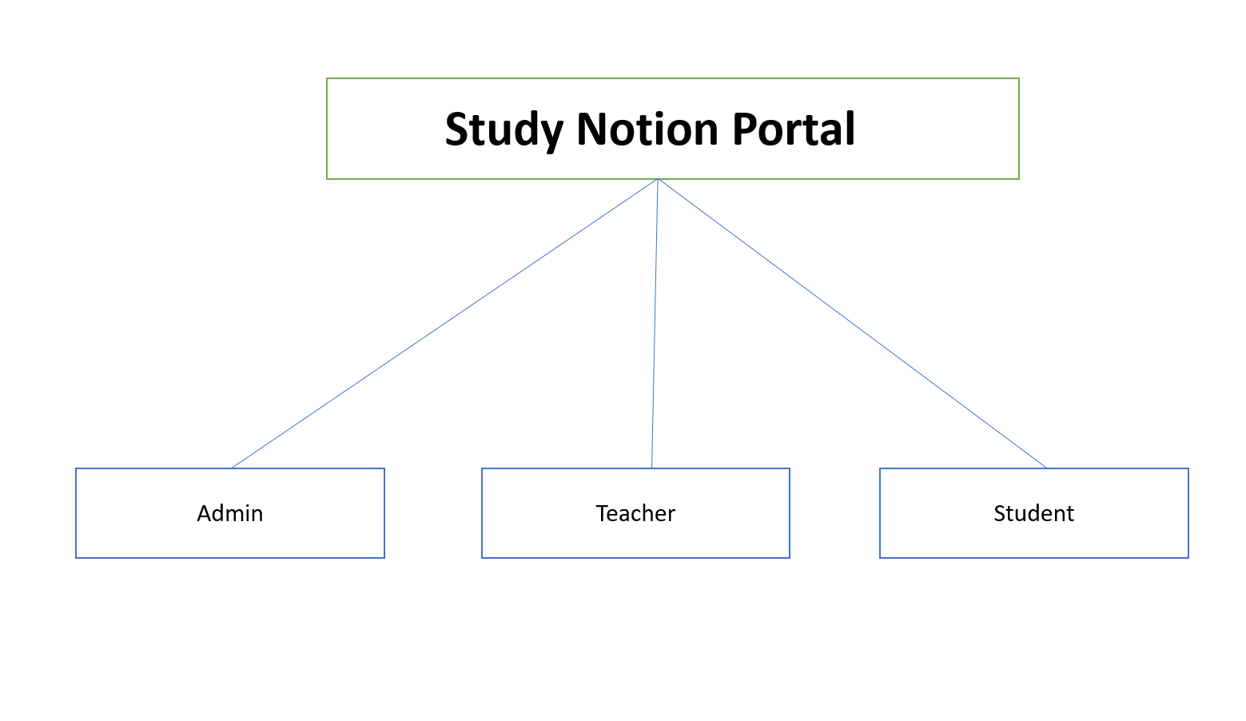

**Study Notion Portal Architecture**

**Fig:3.1.1**

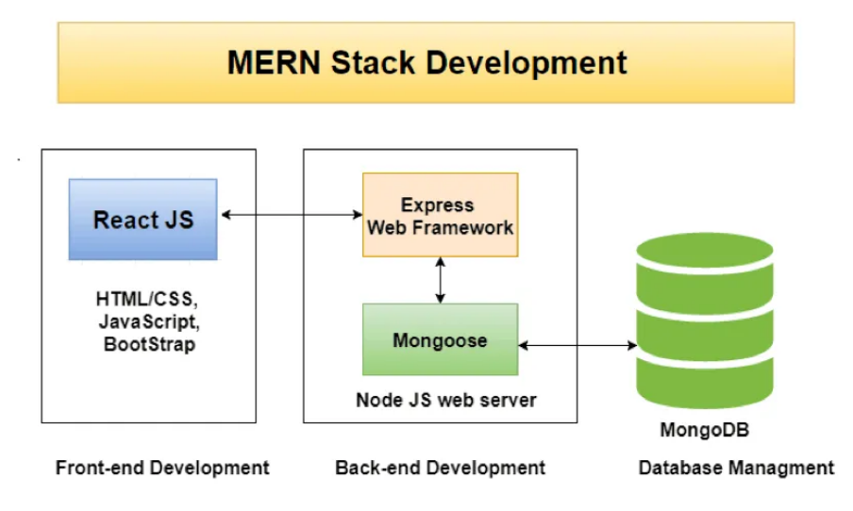

**MERN Stack Development**

**Fig:3.1.2**

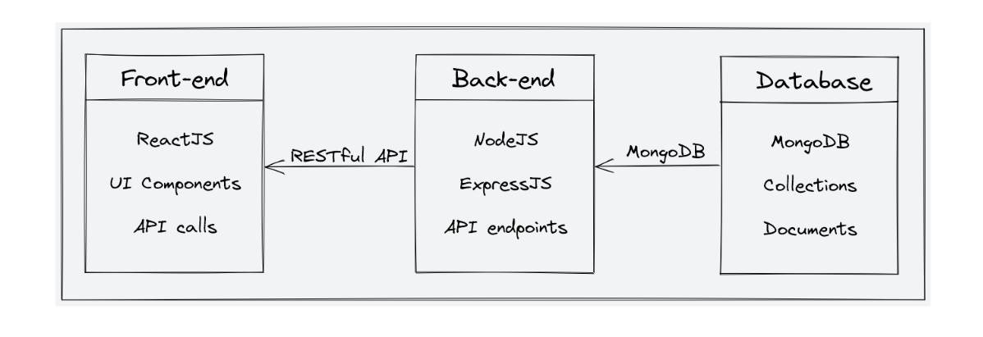

**Font-End, Back-End and DataBase of Study Notion Portal**

**Fig:3.1.3**

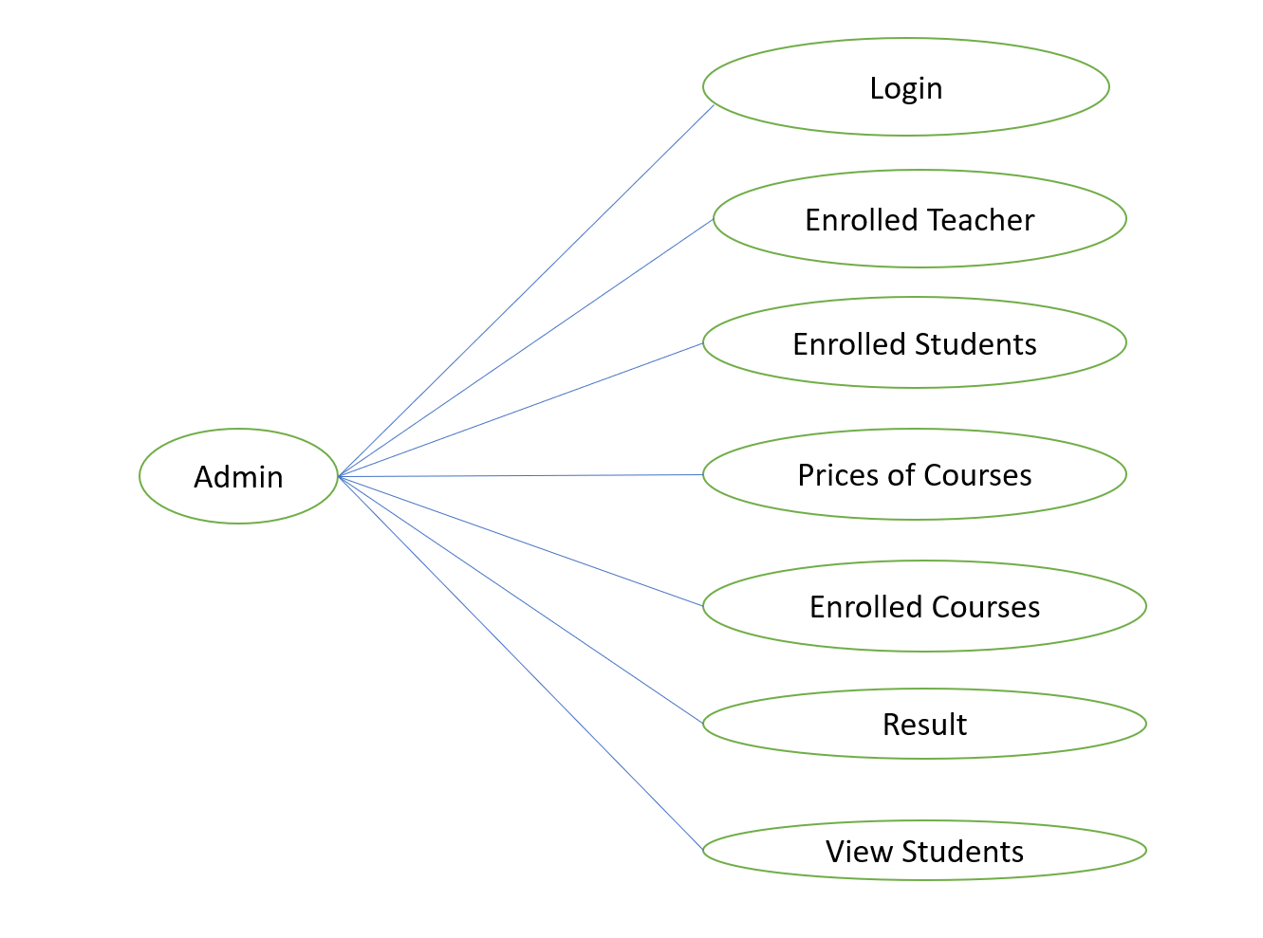

**Admin Flow Chart**

**Fig:3.1.4**

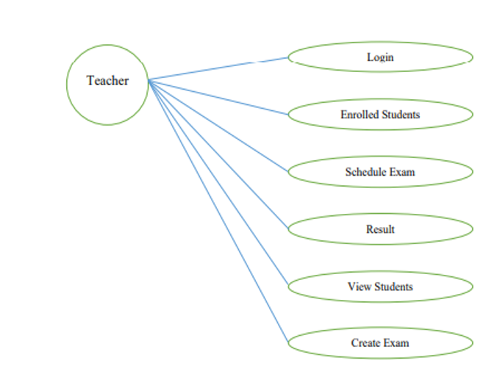

**Teacher Flow Chart**

**Fig:3.1.5**

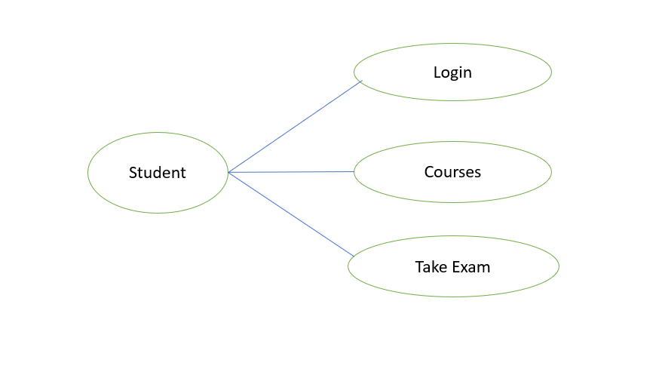

**Student Flow Chart**

**Fig:3.1.6**

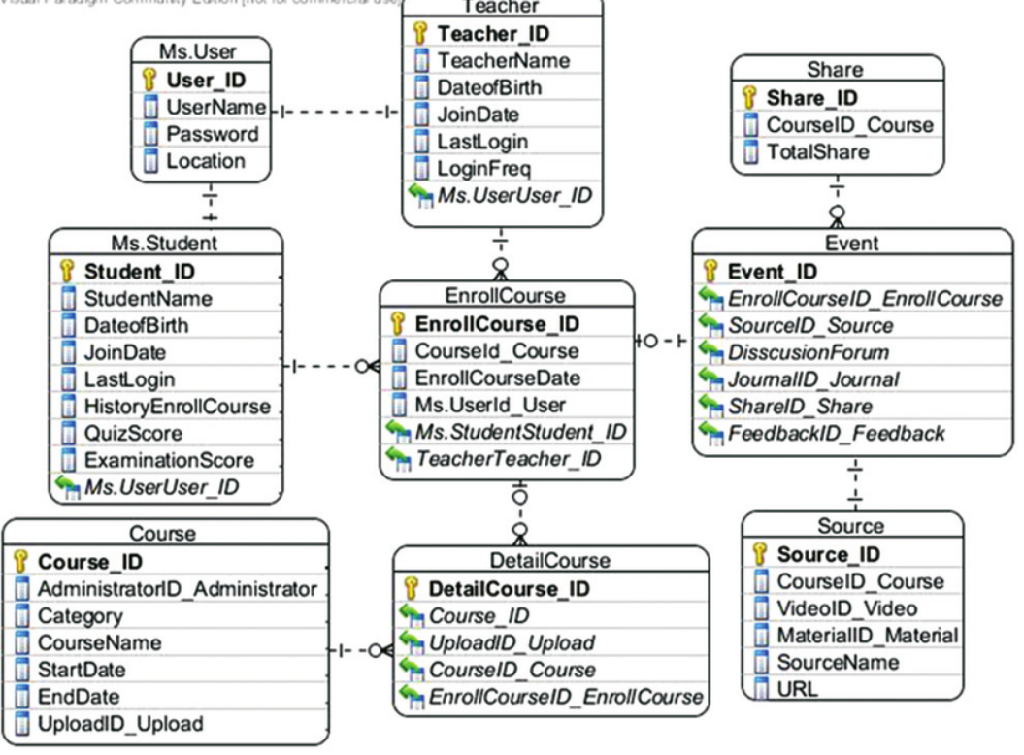

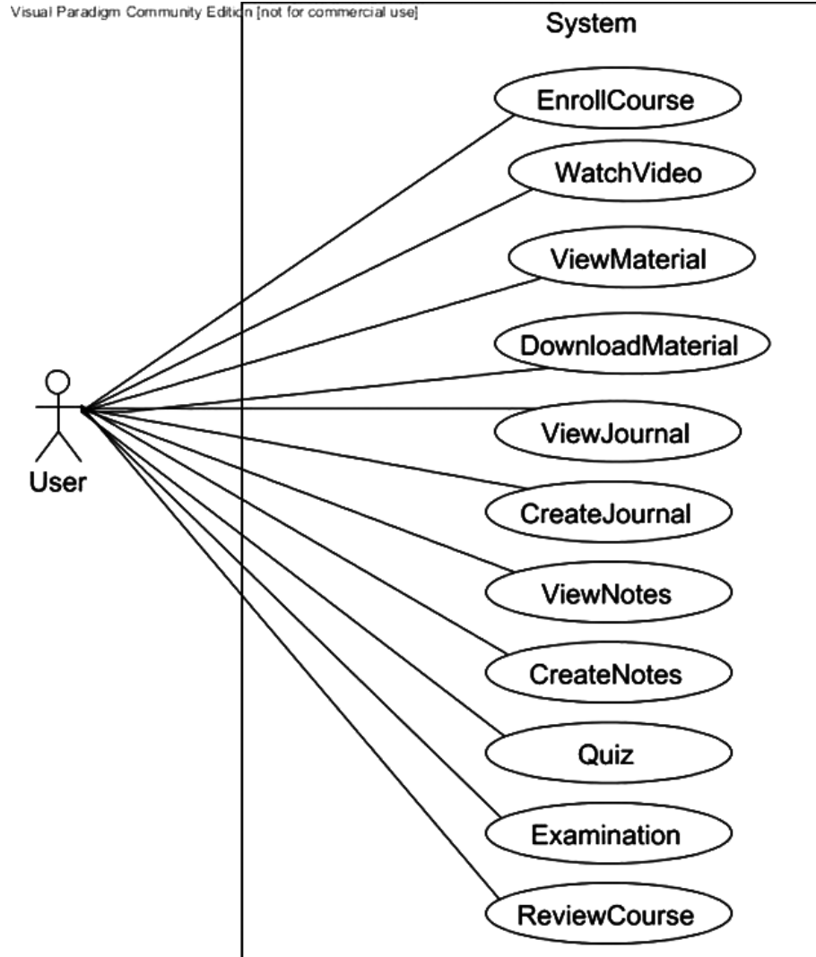

**User Flow Diagram**

**Fig:3.1.8**

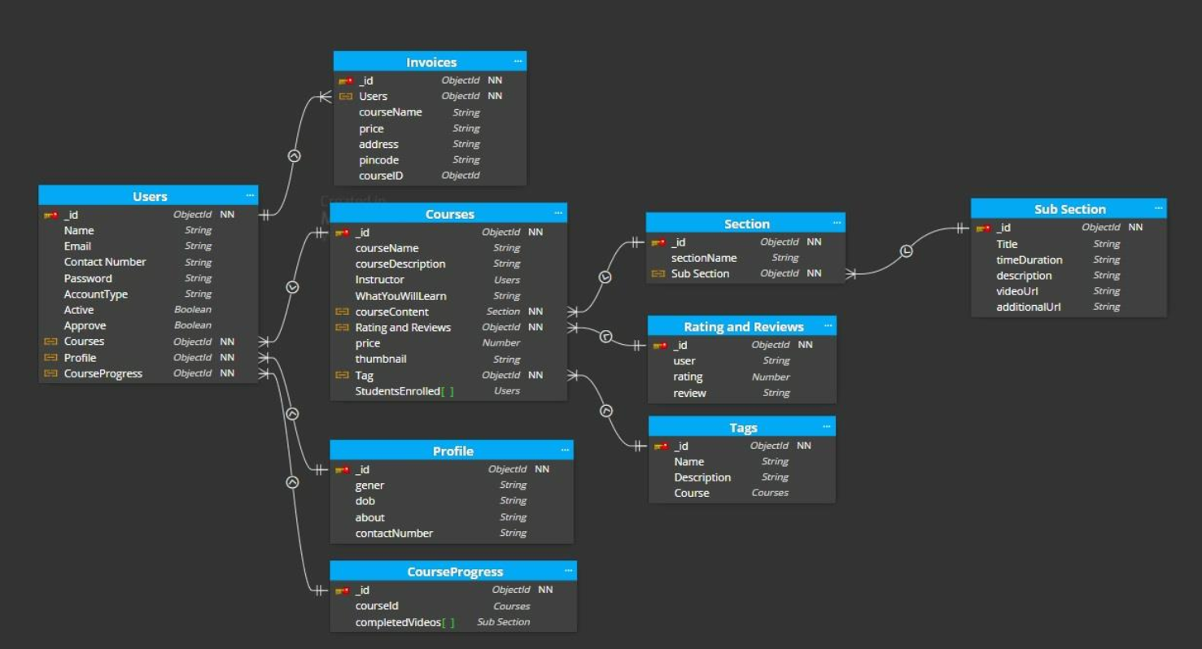

**API Working of Study Notion Portal**

**Fig:3.1.9**

**3.2 Methodology**

**3.2.1 Data Selection**

The selection of relevant data is critical for the success of the recommender system. This phase involves identifying and gathering datasets related to user interactions with the Study Notion portal Website, including users, courses preferences, and historical data.

**3.2.2 Data Pre-Processing**

Data pre-processing involves cleaning and transforming raw data into a usable format. It includes handling missing values, removing duplicates, and addressing inconsistencies to ensure data quality.

**3.2.3 Data Transformation**

Transformation of data involves converting raw data into a suitable format for modeling. This includes encoding categorical variables, scaling numerical features, and preparing the data for recommender system implementation.

**3.2.4 Modelling**

The modeling phase focuses on the selection and implementation of the recommender system algorithm. In this case, the study utilizes item-based collaborative filtering for generating personalized recommendations.

**3.2.5 Evaluation**

The evaluation process involves assessing the performance of the implemented recommender system. Metrics such as precision, recall, and Mean Squared Error (MSE) are employed to measure the accuracy and effectiveness of the recommendations.

**3.3 Logical Flow of the System**

This section provides a step-by-step logical flow of the recommender system implementation within the Study Notion Portal Website, from data selection to evaluation.

**3.4 Item-based Collaborative Filtering**

**3.4.1 Item-Similarity Computation**

Item-based collaborative filtering relies on calculating the similarity between items based on user interactions. This involves computing item similarity scores to identify items with similar user preferences.

**3.5 Rating Prediction Computation**

The recommender system predicts user ratings for items based on historical data, enabling the system to understand user preferences and recommend relevant items.

**3.6 Generating Recommendation**

The final step involves generating personalized recommendations for users based on their historical interactions and predicted ratings.

**3.7 Tools**

**3.7.1 Python**

Python is the primary programming language for implementing the recommender system and the Study Notion Portal Website.

**3.7.2 Graph lab Create**

Graph lab Create provides a comprehensive toolkit for building and deploying machine learning models, including recommender systems.

**3.7.3 Pandas**

Pandas is used for data manipulation and analysis, facilitating efficient data pre-processing.

**3.7.4 NLTK**

Natural Language Toolkit (NLTK) supports text processing, enabling the system to understand and analyze textual data related to user preferences.

**3.7.5 Flask**

Flask is employed for developing the interface of the Exam-Portal Website, providing a user-friendly platform for interaction.

**3.8 Summary**

This chapter has outlined the research methodology, including data selection, pre-processing, transformation, modelling , and evaluation. The logical flow of the system, along with the tools used, sets the foundation for the implementation phase.

**CHAPTER 4**

**IMPLEMENTATION**

**4.1 Introduction**

This chapter delves into the practical implementation of the Study Notion Portal Website, focusing on dataset selection, exploratory data analysis, data cleaning, partitioning, and the implementation of the recommender system.

**4.2 Dataset**

**4.2.1 Business**

The business dataset encompasses information related to courses, user profiles, and historical interactions within the Study Notion Website.

**4.2.2 User**

The user dataset includes demographic information, preferences, and historical data reflecting user interactions with the platform.

**4.3 Exploratory Data Analysis**

Exploratory Data Analysis (EDA) involves a detailed examination of the datasets to identify patterns, trends, and insights that inform the recommender system implementation.

**4.4 Data Cleaning**

**4.4.1 Business Dataset**

Data cleaning involves addressing missing values, removing duplicates, and resolving inconsistencies in the business dataset.

**4.5 Data Partitioning**

The dataset is partitioned into training and testing sets to facilitate the evaluation of the recommender system's performance.

**4.6 Model Implementation**

**4.6.1 Data Staging**

Data staging involves preparing the dataset for recommender system implementation through encoding, scaling, and other pre-processing steps.

**4.6.2 Model Building**

The recommender system model is built using item-based collaborative filtering, utilizing item-similarity computation and rating prediction.

**4.6.3 Recommender System Interface**

The Study Notion Portal Website interface is developed to seamlessly integrate the recommender system, providing users with personalized recommendations.

**4.7 Summary**

This chapter has provided insights into the practical implementation of the Study Notion Portal Website, emphasizing dataset selection, exploratory data analysis, data cleaning, partitioning, and recommender system integration.

**CHAPTER 5**

**RESULTS AND EVALUATION**

**5.1 Introduction**

This chapter presents the results obtained from the implementation of the Study Notion Portal Website and the evaluation of the recommender system.

**5.2 Project Interface**

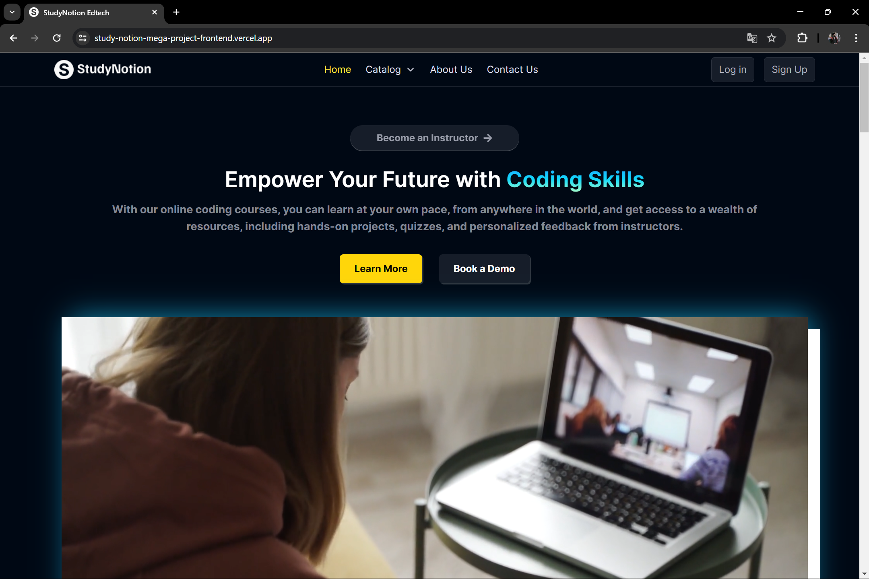

**5.3 Student Sign Up Page Code and Interface**

import { useState } from "react"

import { toast } from "react-hot-toast"

import { AiOutlineEye, AiOutlineEyeInvisible } from "react-icons/ai"

import { useDispatch } from "react-redux"

import { useNavigate } from "react-router-dom"

import { sendOtp } from "../../../services/operations/authAPI"

import { setSignupData } from "../../../slices/authSlice"

import { ACCOUNT_TYPE } from "../../../utils/constants"

import Tab from "../../common/Tab"

function SignupForm() {

  const navigate = useNavigate()

  const dispatch = useDispatch()

  // student or instructor

  const [accountType, setAccountType] = useState(ACCOUNT_TYPE.STUDENT)

  const [formData, setFormData] = useState({

    firstName: "",

    lastName: "",

    email: "",

    password: "",

    confirmPassword: "",

  })

  const [showPassword, setShowPassword] = useState(false)

  const [showConfirmPassword, setShowConfirmPassword] = useState(false)

  const { firstName, lastName, email, password, confirmPassword } = formData

  // Handle input fields, when some value changes

  const handleOnChange = (e) => {

    setFormData((prevData) => ({

      ...prevData,

      [e.target.name]: e.target.value,

    }))

  }

  // Handle Form Submission

  const handleOnSubmit = (e) => {

    e.preventDefault()

    if (password !== confirmPassword) {

      toast.error("Passwords Do Not Match")

      return

    }

    const signupData = {

      ...formData,

      accountType,

    }

    // Setting signup data to state

    // To be used after otp verification

    dispatch(setSignupData(signupData))

    // Send OTP to user for verification

    dispatch(sendOtp(formData.email, navigate))

    // Reset

    setFormData({

      firstName: "",

      lastName: "",

      email: "",

      password: "",

      confirmPassword: "",

    })

    setAccountType(ACCOUNT_TYPE.STUDENT)

  }

  // data to pass to Tab component

  const tabData = [

    {

      id: 1,

      tabName: "Student",

      type: ACCOUNT_TYPE.STUDENT,

    },

    {

      id: 2,

      tabName: "Instructor",

      type: ACCOUNT_TYPE.INSTRUCTOR,

    },

  ]

  return (

    <div>

      {/* Tab */}

      <Tab tabData={tabData} field={accountType} setField={setAccountType} />

      {/* Form */}

      <form onSubmit={handleOnSubmit} className="flex w-full flex-col gap-y-4">

        <div className="flex gap-x-4">

          <label>

            <p className="mb-1 text-[0.875rem] leading-[1.375rem] text-richblack-5">

              First Name <sup className="text-pink-200">*</sup>

            </p>

            <input

              required

              type="text"

              name="firstName"

              value={firstName}

              onChange={handleOnChange}

              placeholder="Enter first name"

              style={{

                boxShadow: "inset 0px -1px 0px rgba(255, 255, 255, 0.18)",

              }}

              className="w-full rounded-[0.5rem] bg-richblack-800 p-[12px] text-richblack-5"

            />

          </label>

          <label>

            <p className="mb-1 text-[0.875rem] leading-[1.375rem] text-richblack-5">

              Last Name <sup className="text-pink-200">*</sup>

            </p>

            <input

              required

              type="text"

              name="lastName"

              value={lastName}

              onChange={handleOnChange}

              placeholder="Enter last name"

              style={{

                boxShadow: "inset 0px -1px 0px rgba(255, 255, 255, 0.18)",

              }}

              className="w-full rounded-[0.5rem] bg-richblack-800 p-[12px] text-richblack-5"

            />

          </label>

        </div>

        <label className="w-full">

          <p className="mb-1 text-[0.875rem] leading-[1.375rem] text-richblack-5">

            Email Address <sup className="text-pink-200">*</sup>

          </p>

          <input

            required

            type="text"

            name="email"

            value={email}

            onChange={handleOnChange}

            placeholder="Enter email address"

            style={{

              boxShadow: "inset 0px -1px 0px rgba(255, 255, 255, 0.18)",

            }}

            className="w-full rounded-[0.5rem] bg-richblack-800 p-[12px] text-richblack-5"

          />

        </label>

        <div className="flex gap-x-4">

          <label className="relative">

            <p className="mb-1 text-[0.875rem] leading-[1.375rem] text-richblack-5">

              Create Password <sup className="text-pink-200">*</sup>

            </p>

            <input

              required

              type={showPassword ? "text" : "password"}

              name="password"

              value={password}

              onChange={handleOnChange}

              placeholder="Enter Password"

              style={{

                boxShadow: "inset 0px -1px 0px rgba(255, 255, 255, 0.18)",

              }}

              className="w-full rounded-[0.5rem] bg-richblack-800 p-[12px] pr-10 text-richblack-5"

            />

            <span

              onClick={() => setShowPassword((prev) => !prev)}

              className="absolute right-3 top-[38px] z-[10] cursor-pointer"

            >

              {showPassword ? (

                <AiOutlineEyeInvisible fontSize={24} fill="#AFB2BF" />

              ) : (

                <AiOutlineEye fontSize={24} fill="#AFB2BF" />

              )}

            </span>

          </label>

          <label className="relative">

            <p className="mb-1 text-[0.875rem] leading-[1.375rem] text-richblack-5">

              Confirm Password <sup className="text-pink-200">*</sup>

            </p>

            <input

              required

              type={showConfirmPassword ? "text" : "password"}

              name="confirmPassword"

              value={confirmPassword}

              onChange={handleOnChange}

              placeholder="Confirm Password"

              style={{

                boxShadow: "inset 0px -1px 0px rgba(255, 255, 255, 0.18)",

              }}

              className="w-full rounded-[0.5rem] bg-richblack-800 p-[12px] pr-10 text-richblack-5"

            />

            <span

              onClick={() => setShowConfirmPassword((prev) => !prev)}

              className="absolute right-3 top-[38px] z-[10] cursor-pointer"

            >

              {showConfirmPassword ? (

                <AiOutlineEyeInvisible fontSize={24} fill="#AFB2BF" />

              ) : (

                <AiOutlineEye fontSize={24} fill="#AFB2BF" />

              )}

            </span>

          </label>

        </div>

        <button

          type="submit"

          className="mt-6 rounded-[8px] bg-yellow-50 py-[8px] px-[12px] font-medium text-richblack-900"

        >

          Create Account

        </button>

      </form>

    </div>

  )

}

export default SignupForm

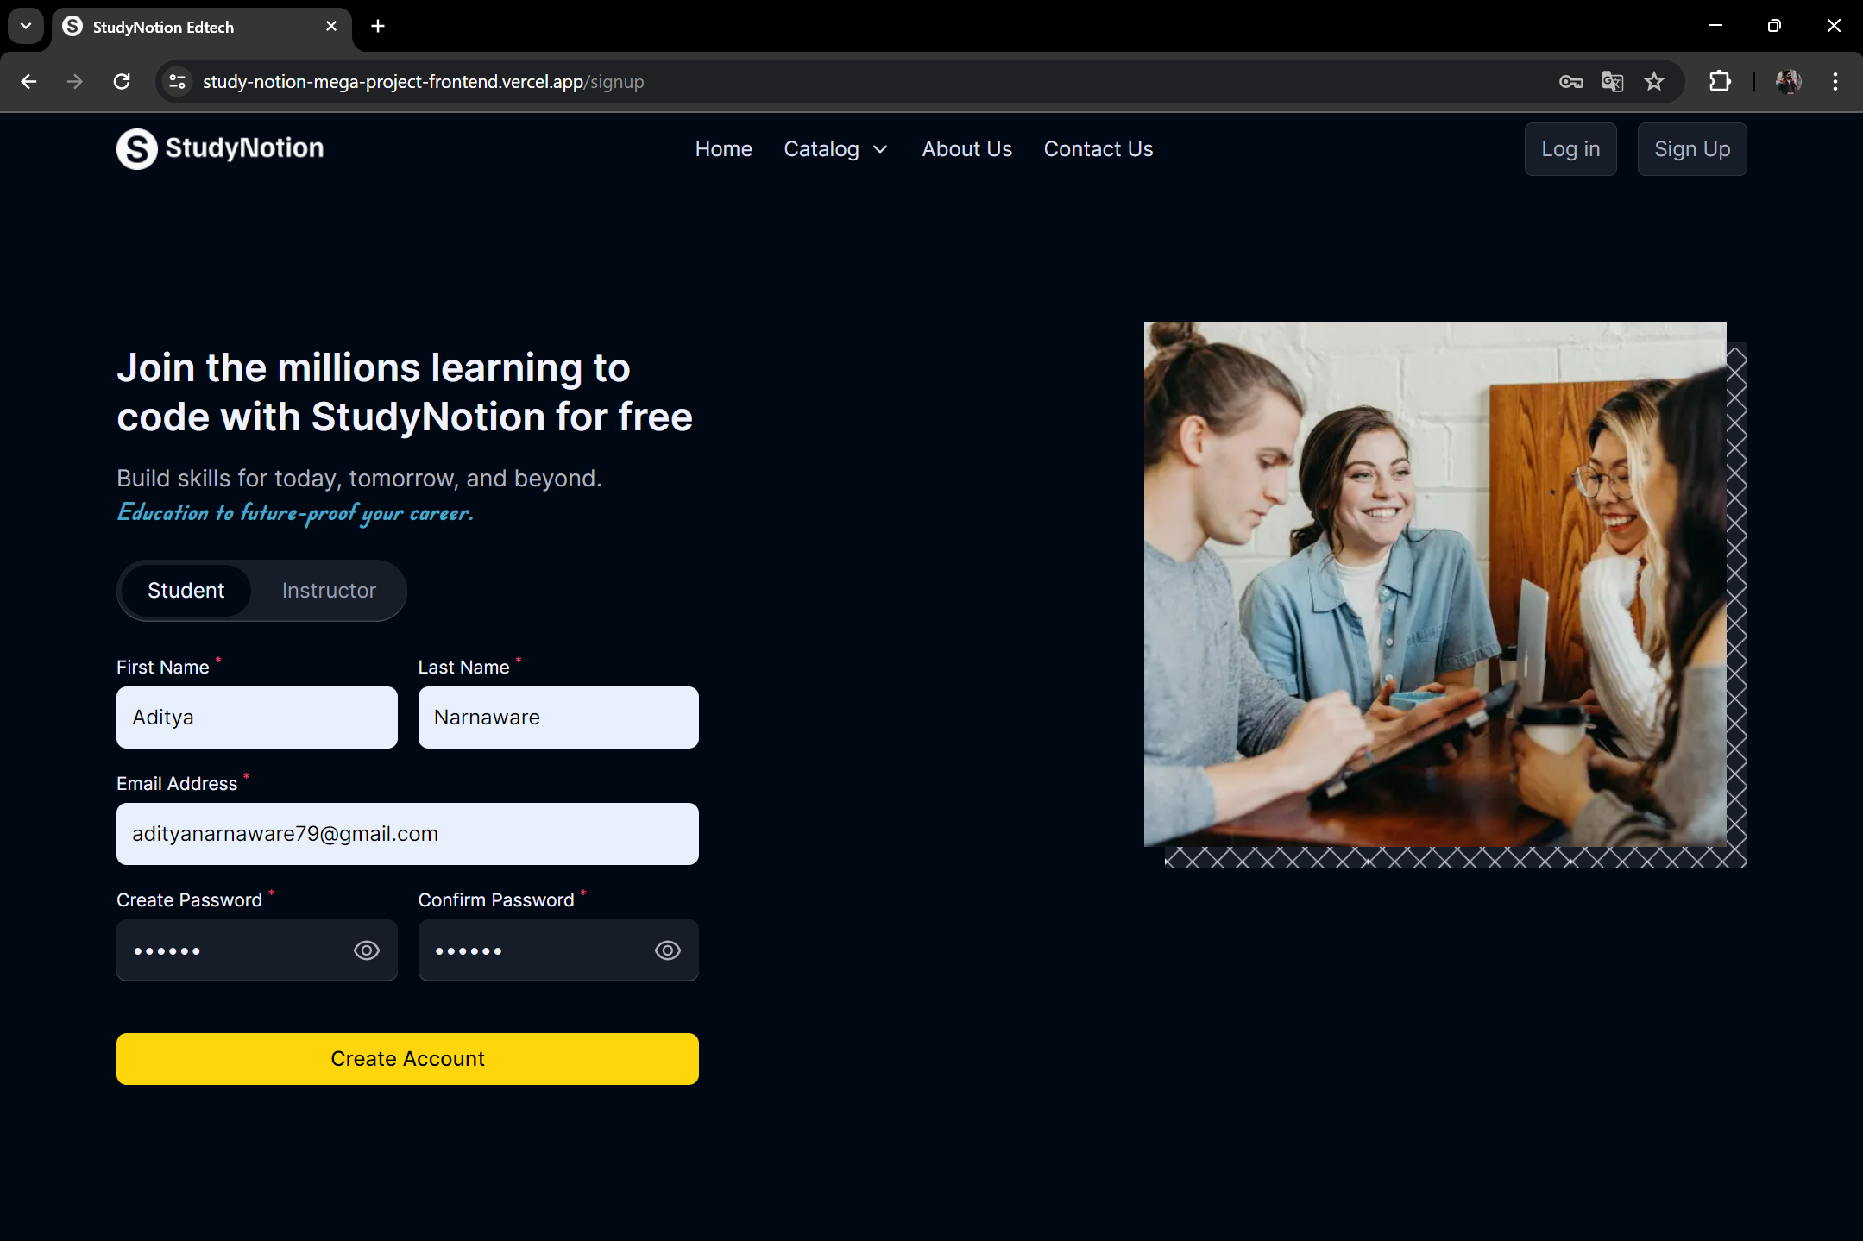

**3.4 Instructor Sign Up Page**

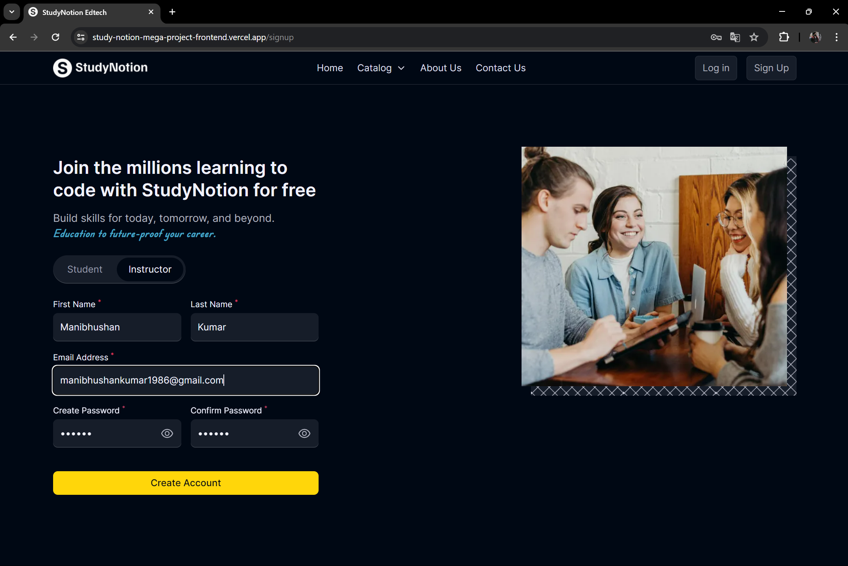

**3.5 Login Page of Study Notion Portal**

import { useState } from "react"

import { AiOutlineEye, AiOutlineEyeInvisible } from "react-icons/ai"

import { useDispatch } from "react-redux"

import { Link, useNavigate } from "react-router-dom"

import { login } from "../../../services/operations/authAPI"

function LoginForm() {

  const navigate = useNavigate()

  const dispatch = useDispatch()

  const [formData, setFormData] = useState({

    email: "",

    password: "",

  })

  const [showPassword, setShowPassword] = useState(false)

  const { email, password } = formData

  const handleOnChange = (e) => {

    setFormData((prevData) => ({

      ...prevData,

      [e.target.name]: e.target.value,

    }))

  }

  const handleOnSubmit = (e) => {

    e.preventDefault()

    dispatch(login(email, password, navigate))

  }

  return (

    <form

      onSubmit={handleOnSubmit}

      className="mt-6 flex w-full flex-col gap-y-4"

    >

      <label className="w-full">

        <p className="mb-1 text-[0.875rem] leading-[1.375rem] text-richblack-5">

          Email Address <sup className="text-pink-200">*</sup>

        </p>

        <input

          required

          type="text"

          name="email"

          value={email}

          onChange={handleOnChange}

          placeholder="Enter email address"

          style={{

            boxShadow: "inset 0px -1px 0px rgba(255, 255, 255, 0.18)",

          }}

          className="w-full rounded-[0.5rem] bg-richblack-800 p-[12px] text-richblack-5"

        />

      </label>

      <label className="relative">

        <p className="mb-1 text-[0.875rem] leading-[1.375rem] text-richblack-5">

          Password <sup className="text-pink-200">*</sup>

        </p>

        <input

          required

          type={showPassword ? "text" : "password"}

          name="password"

          value={password}

          onChange={handleOnChange}

          placeholder="Enter Password"

          style={{

            boxShadow: "inset 0px -1px 0px rgba(255, 255, 255, 0.18)",

          }}

          className="w-full rounded-[0.5rem] bg-richblack-800 p-[12px] pr-12 text-richblack-5"

        />

        <span

          onClick={() => setShowPassword((prev) => !prev)}

          className="absolute right-3 top-[38px] z-[10] cursor-pointer"

        >

          {showPassword ? (

            <AiOutlineEyeInvisible fontSize={24} fill="#AFB2BF" />

          ) : (

            <AiOutlineEye fontSize={24} fill="#AFB2BF" />

          )}

        </span>

        <Link to="/forgot-password">

          <p className="mt-1 ml-auto max-w-max text-xs text-blue-100">

            Forgot Password

          </p>

        </Link>

      </label>

      <button

        type="submit"

        className="mt-6 rounded-[8px] bg-yellow-50 py-[8px] px-[12px] font-medium text-richblack-900"

      >

        Sign In

      </button>

    </form>

  )

}

export default LoginForm

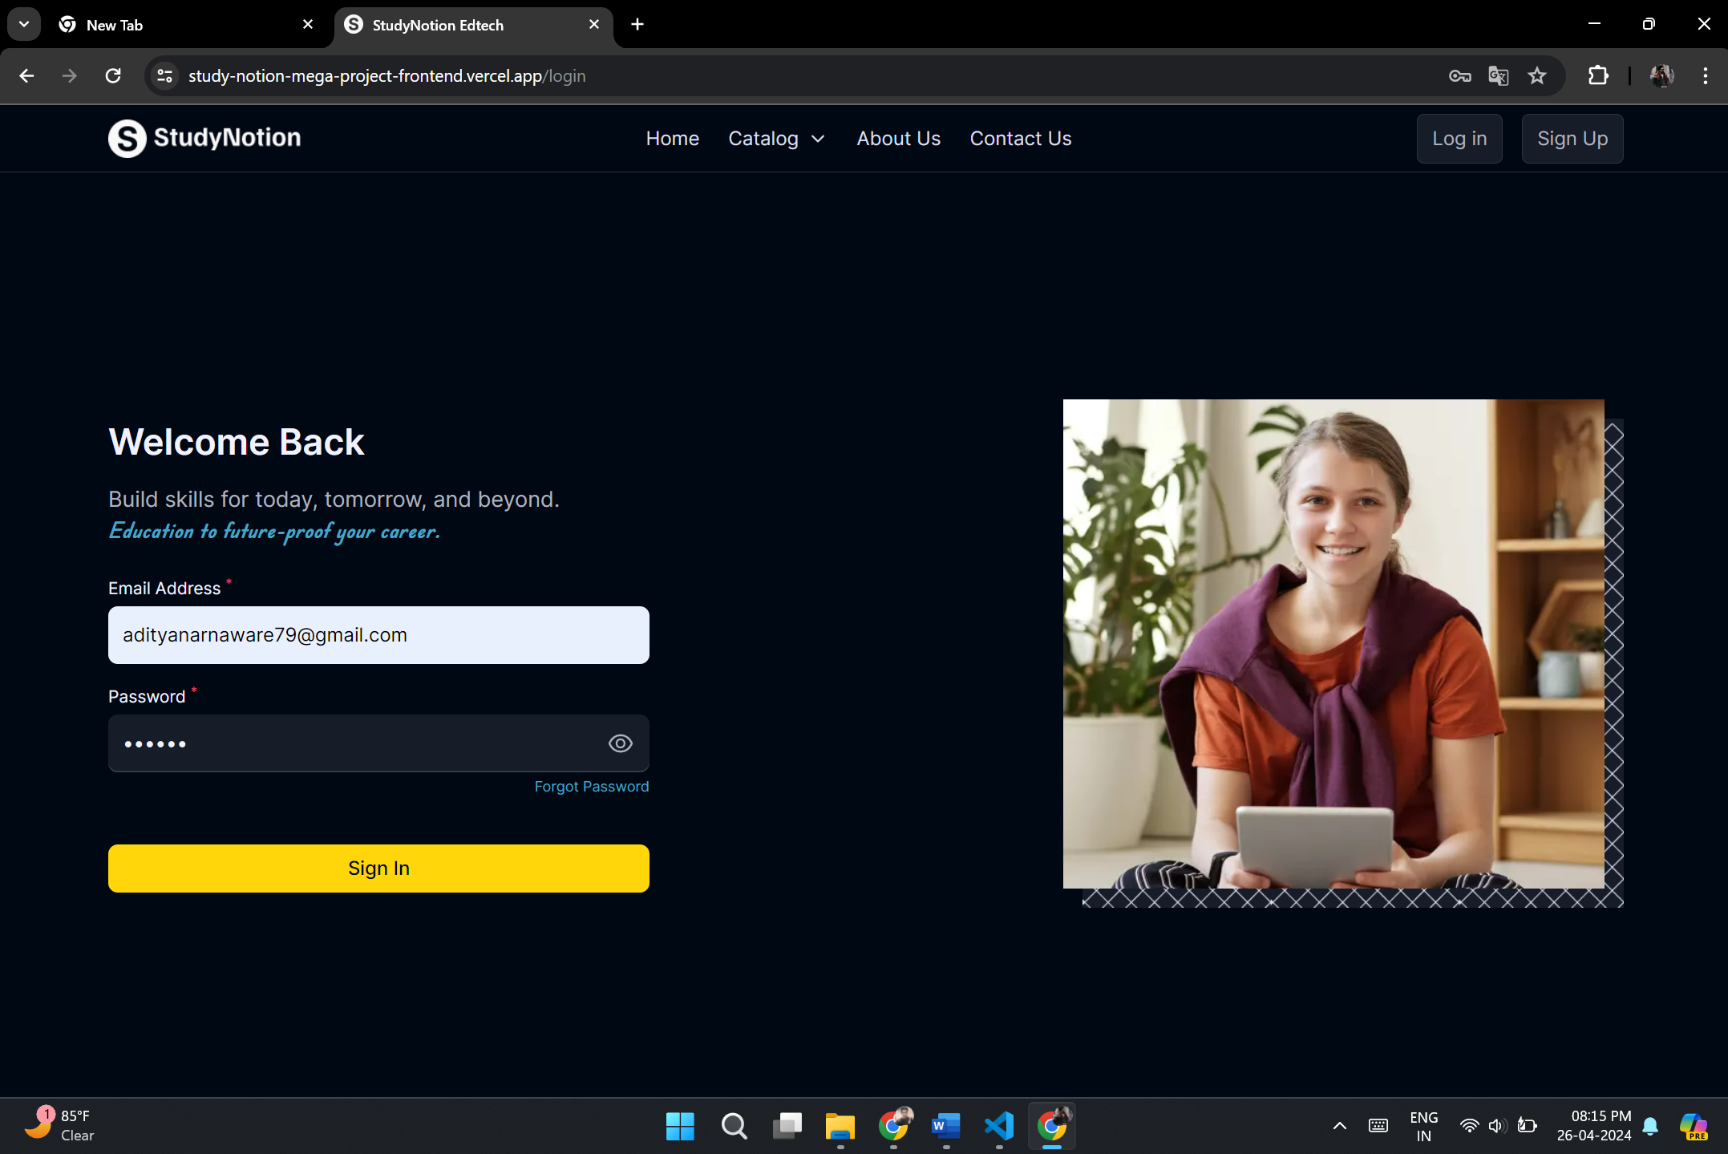

**3.6 OTP Verification on Email**

const otpTemplate = (otp) => {

  return `<!DOCTYPE html>

    <html>

    <head>

        <meta charset="UTF-8">

        <title>OTP Verification Email</title>

        <style>

            body {

                background-color: #ffffff;

                font-family: Arial, sans-serif;

                font-size: 16px;

                line-height: 1.4;

                color: #333333;

                margin: 0;

                padding: 0;

            }

            .container {

                max-width: 600px;

                margin: 0 auto;

                padding: 20px;

                text-align: center;

            }

            .logo {

                max-width: 200px;

                margin-bottom: 20px;

            }

            .message {

                font-size: 18px;

                font-weight: bold;

                margin-bottom: 20px;

            }

            .body {

                font-size: 16px;

                margin-bottom: 20px;

            }

            .cta {

                display: inline-block;

                padding: 10px 20px;

                background-color: #FFD60A;

                color: #000000;

                text-decoration: none;

                border-radius: 5px;

                font-size: 16px;

                font-weight: bold;

                margin-top: 20px;

            }

            .support {

                font-size: 14px;

                color: #999999;

                margin-top: 20px;

            }

            .highlight {

                font-weight: bold;

            }

        </style>

    </head>

    <body>

        <div class="container">

            <a href="https://studynotion-edtech-project.vercel.app"><img class="logo"

                    src="https://i.ibb.co/7Xyj3PC/logo.png" alt="StudyNotion Logo"></a>

            <div class="message">OTP Verification Email</div>

            <div class="body">

                <p>Dear User,</p>

                <p>Thank you for registering with StudyNotion. To complete your registration, please use the following OTP

                    (One-Time Password) to verify your account:</p>

                <h2 class="highlight">${otp}</h2>

                <p>This OTP is valid for 5 minutes. If you did not request this verification, please disregard this email.

                Once your account is verified, you will have access to our platform and its features.</p>

            </div>

            <div class="support">If you have any questions or need assistance, please feel free to reach out to us at <a

                    href="mailto:info@studynotion.com">info@studynotion.com</a>. We are here to help!</div>

        </div>

    </body>

    </html>`;

};

module.exports = otpTemplate;

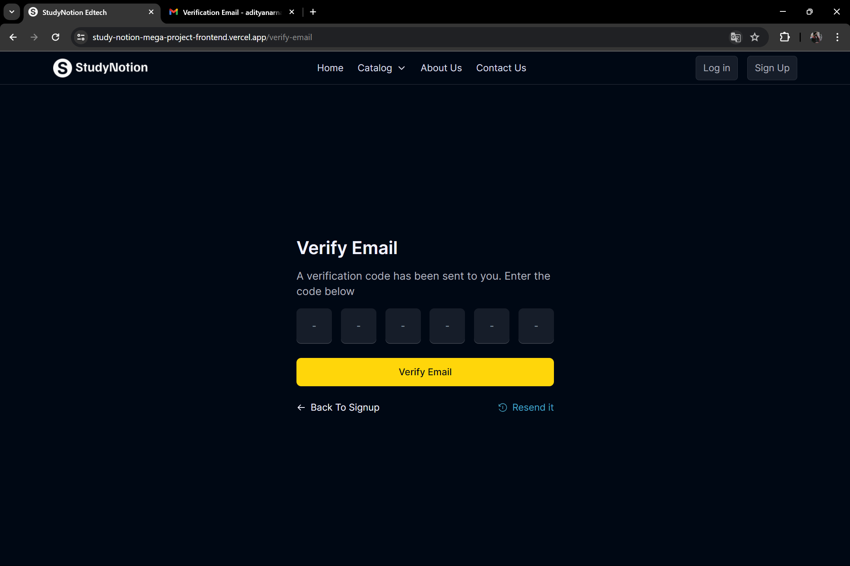

**3.7 Getting OTP verification code on E-mail**

const mongoose = require("mongoose");

const mailSender = require("../utils/mailSender");

const emailTemplate = require("../mail/templates/emailVerificationTemplate");

const OTPSchema = new mongoose.Schema({

  email: {

    type: String,

    required: true,

  },

  otp: {

    type: String,

    required: true,

  },

  createdAt: {

    type: Date,

    default: Date.now(),

    expires: 5 * 60, // The document will be automatically deleted after 5 minutes of its creation time

  },

});

async function sendVerficationEmail(email, otp) {

  try {

    const mailResponse = await mailSender(

      email,

      "Varification Email from StudyNotion",

      emailTemplate(otp)

    );

  } catch (error) {

    console.log("error occured while sending mailes:", error);

    throw error;

  }

}

OTPSchema.pre("save", async function (next) {

  await sendVerficationEmail(this.email, this.otp);

  next();

});

module.exports = mongoose.model("OTP", OTPSchema);

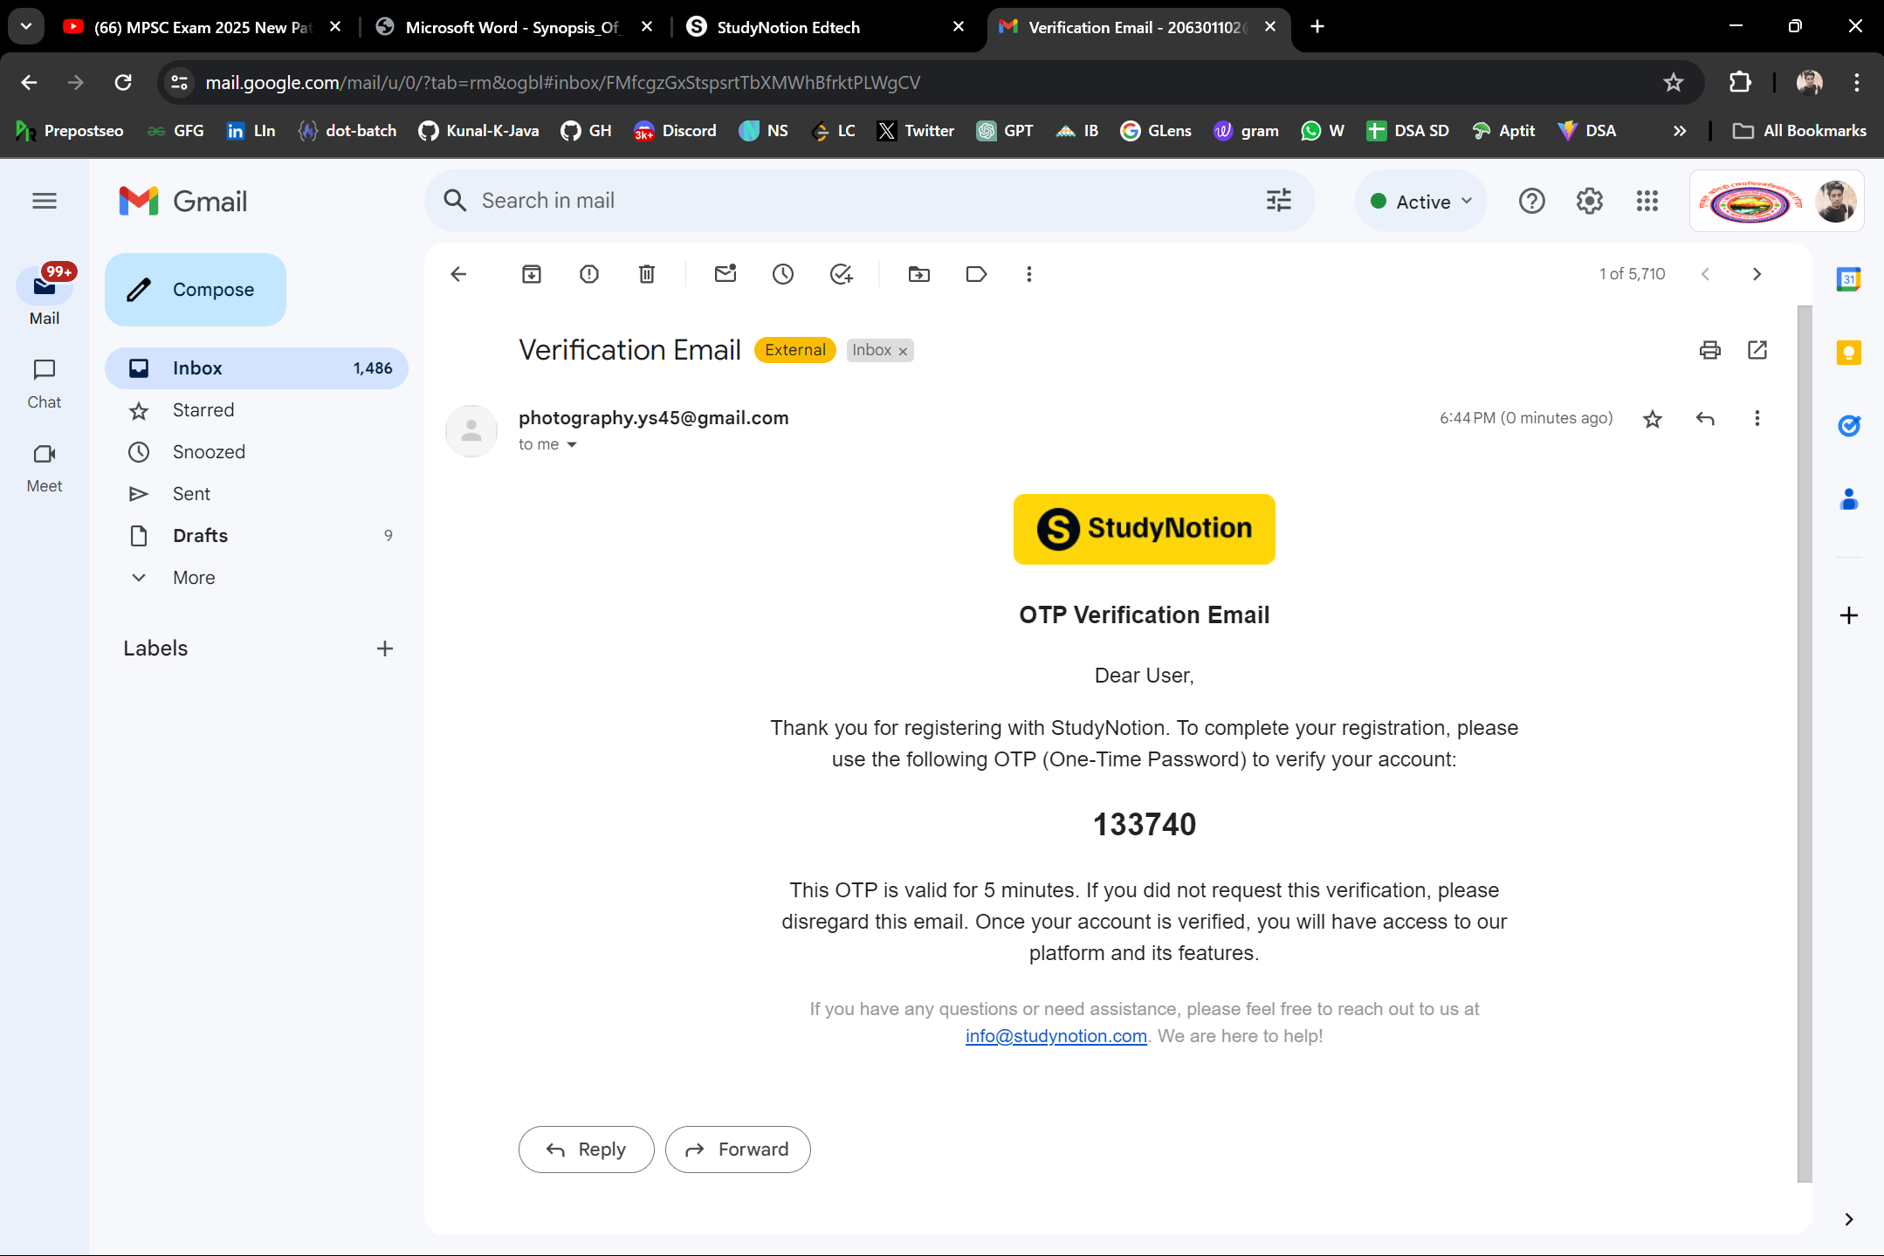

**3.8 Home page of Study Notion Portal**

import { useSelector } from "react-redux"

import { Outlet } from "react-router-dom"

import Sidebar from "../components/core/Dashboard/Sidebar"

function Dashboard() {

  const { loading: profileLoading } = useSelector((state) => state.profile)

  const { loading: authLoading } = useSelector((state) => state.auth)

  if (profileLoading || authLoading) {

    return (

      <div className="grid min-h-[calc(100vh-3.5rem)] place-items-center">

        <div className="spinner"></div>

      </div>

    )

  }

  return (

    <div className="relative flex min-h-[calc(100vh-3.5rem)]">

      <Sidebar />

      <div className="h-[calc(100vh-3.5rem)] flex-1 overflow-auto">

        <div className="mx-auto w-11/12 max-w-[1000px] py-10">

          <Outlet />

        </div>

      </div>

    </div>

  )

}

export default Dashboard

import React, { useEffect, useState } from "react";

import { useSelector } from "react-redux";

import { fetchInstructorCourses } from "../../../../services/operations/courseDetailsAPI";

import { getInstructorData } from "../../../../services/operations/profileAPI";

import InstructorChart from "./InstructorChart";

import { Link } from "react-router-dom";

export default function Instructor() {

  const { token } = useSelector((state) => state.auth);

  const { user } = useSelector((state) => state.profile);

  const [loading, setLoading] = useState(false);

  const [instructorData, setInstructorData] = useState(null);

  const [courses, setCourses] = useState([]);

  useEffect(() => {

    (async () => {

      setLoading(true);

      const instructorApiData = await getInstructorData(token);

      console.log("instructorApiData------------->>", instructorApiData);

      const result = await fetchInstructorCourses(token);

      console.log(

        "      const result = await fetchInstructorCourses ApiData------------->>",

        result

      );

      if (instructorApiData.length) setInstructorData(instructorApiData);

      if (result) {

        setCourses(result);

      }

      setLoading(false);

    })();

  }, []);

  console.log("instructorData useState------>", instructorData);

  const totalAmount = instructorData?.reduce((acc, curr) => acc + curr.totalAmountGenerated,0);

  // console.log("instructorData?.reduce()-----", instructorData?.reduce());

  console.log("totalAmountGenerated------>", totalAmount);

  const totalStudents = instructorData?.reduce(

    (acc, curr) => acc + curr.totalStudentsEnrolled,

    0

  );

  console.log("totalStudentsEnrolled------>", totalStudents);

  return (

    <div>

      <div className="space-y-2">

        <h1 className="text-2xl font-bold text-richblack-5">

          Hi {user?.firstName} 👋

        </h1>

        <p className="font-medium text-richblack-200">

          Let's start something new

        </p>

      </div>

      {loading ? (

        <div className="spinner"></div>

      ) : courses.length > 0 ? (

        <div>

          <div className="my-4 flex h-[450px] space-x-4">

            {/* Render chart / graph */}

            {totalAmount > 0 || totalStudents > 0 ? (

              <InstructorChart courses={instructorData} />

            ) : (

              <div className="flex-1 rounded-md bg-richblack-800 p-6">

                <p className="text-lg font-bold text-richblack-5">Visualize</p>

                <p className="mt-4 text-xl font-medium text-richblack-50">

                  Not Enough Data To Visualize

                </p>

              </div>

            )}

            {/* Total Statistics */}

            <div className="flex min-w-[250px] flex-col rounded-md bg-richblack-800 p-6">

              <p className="text-lg font-bold text-richblack-5">Statistics</p>

              <div className="mt-4 space-y-4">

                <div>

                  <p className="text-lg text-richblack-200">Total Courses</p>

                  <p className="text-3xl font-semibold text-richblack-50">

                    {courses.length}

                  </p>

                </div>

                <div>

                  <p className="text-lg text-richblack-200">Total Students</p>

                  <p className="text-3xl font-semibold text-richblack-50">

                    {totalStudents}

                  </p>

                </div>

                <div>

                  <p className="text-lg text-richblack-200">Total Income</p>

                  <p className="text-3xl font-semibold text-richblack-50">

                    Rs. {totalAmount}

                  </p>

                </div>

              </div>

            </div>

          </div>

          <div className="rounded-md bg-richblack-800 p-6">

            {/* Render 3 courses */}

            <div className="flex items-center justify-between">

              <p className="text-lg font-bold text-richblack-5">Your Courses</p>

              <Link to="/dashboard/my-courses">

                <p className="text-xs font-semibold text-yellow-50">View All</p>

              </Link>

            </div>

            <div className="my-4 flex items-start space-x-6">

              {courses.slice(0, 3).map((course) => (

                <div key={course._id} className="w-1/3">

                  <img

                    src={course.thumbnail}

                    alt={course.courseName}

                    className="h-[201px] w-full rounded-md object-cover"

                  />

                  <div className="mt-3 w-full">

                    <p className="text-sm font-medium text-richblack-50">

                      {course.courseName}

                    </p>

                    <div className="mt-1 flex items-center space-x-2">

                      <p className="text-xs font-medium text-richblack-300">

                        {course?.studentsEnroled?.length} students

                      </p>

                      <p className="text-xs font-medium text-richblack-300">

                        |

                      </p>

                      <p className="text-xs font-medium text-richblack-300">

                        Rs. {course.price}

                      </p>

                    </div>

                  </div>

                </div>

              ))}

            </div>

          </div>

        </div>

      ) : (

        <div className="mt-20 rounded-md bg-richblack-800 p-6 py-20">

          <p className="text-center text-2xl font-bold text-richblack-5">

            You have not created any courses yet

          </p>

          <Link to="/dashboard/add-course">

            <p className="mt-1 text-center text-lg font-semibold text-yellow-50">

              Create a course

            </p>

          </Link>

        </div>

      )}

    </div>

  );

}

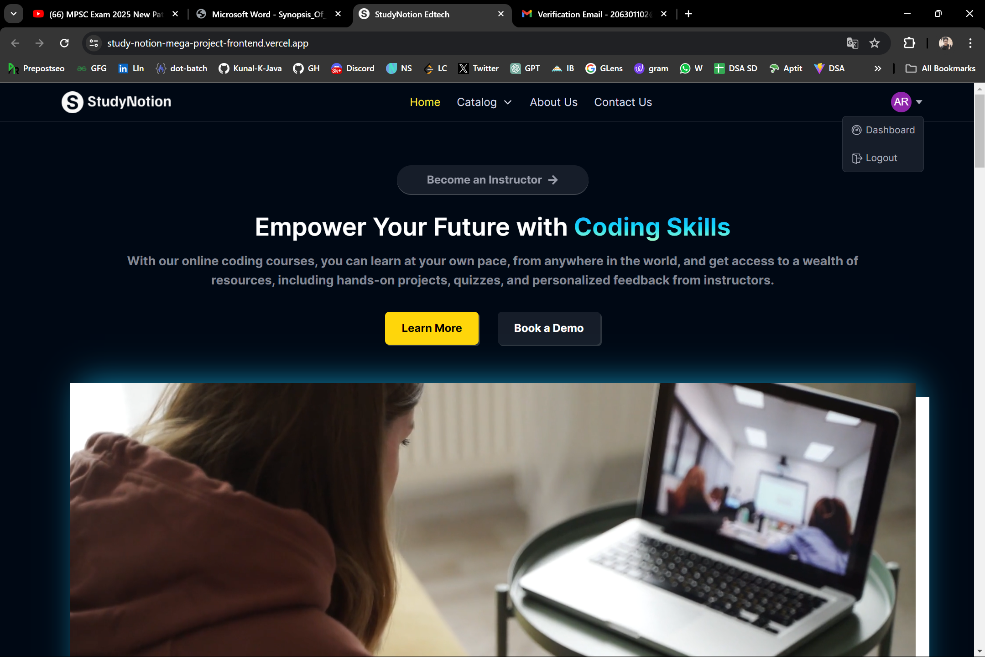

**3.9 My Profile Section**

import { RiEditBoxLine } from "react-icons/ri";

import { useSelector } from "react-redux";

import { useNavigate } from "react-router-dom";

import { formattedDate } from "../../../utils/dateFormatter";

import IconBtn from "../../common/IconBtn";

export default function MyProfile() {

  const { user } = useSelector((state) => state.profile);

  const navigate = useNavigate();

  return (

    <>

      <h1 className="mb-14 text-3xl font-medium text-richblack-5">

        My Profile

      </h1>

      <div className="flex items-center justify-between rounded-md border-[1px] border-richblack-700 bg-richblack-800 p-8 px-12">

        <div className="flex items-center gap-x-4">

          <img

            src={user?.image}

            alt={`profile-${user?.firstName}`}

            className="aspect-square w-[78px] rounded-full object-cover"

          />

          <div className="space-y-1">

            <p className="text-lg font-semibold text-richblack-5">

              {user?.firstName + " " + user?.lastName}

            </p>

            <p className="text-sm text-richblack-300">{user?.email}</p>

          </div>

        </div>

        <IconBtn

          text="Edit"

          onclick={() => {

            navigate("/dashboard/settings");

          }}

        >

          <RiEditBoxLine />

        </IconBtn>

      </div>

      <div className="my-10 flex flex-col gap-y-10 rounded-md border-[1px] border-richblack-700 bg-richblack-800 p-8 px-12">

        <div className="flex w-full items-center justify-between">

          <p className="text-lg font-semibold text-richblack-5">About</p>

          <IconBtn

            text="Edit"

            onclick={() => {

              navigate("/dashboard/settings");

            }}

          >

            <RiEditBoxLine />

          </IconBtn>

        </div>

        <p

          className={`${

            user?.additionalDetails?.about

              ? "text-richblack-5"

              : "text-richblack-400"

          } text-sm font-medium`}

        >

          {user?.additionalDetails?.about ?? "Write Something About Yourself"}

        </p>

      </div>

      <div className="my-10 flex flex-col gap-y-10 rounded-md border-[1px] border-richblack-700 bg-richblack-800 p-8 px-12">

        <div className="flex w-full items-center justify-between">

          <p className="text-lg font-semibold text-richblack-5">

            Personal Details

          </p>

          <IconBtn

            text="Edit"

            onclick={() => {

              navigate("/dashboard/settings");

            }}

          >

            <RiEditBoxLine />

          </IconBtn>

        </div>

        <div className="flex max-w-[500px] justify-between">

          <div className="flex flex-col gap-y-5">

            <div>

              <p className="mb-2 text-sm text-richblack-600">First Name</p>

              <p className="text-sm font-medium text-richblack-5">

                {user?.firstName}

              </p>

            </div>

            <div>

              <p className="mb-2 text-sm text-richblack-600">Email</p>

              <p className="text-sm font-medium text-richblack-5">

                {user?.email}

              </p>

            </div>

            <div>

              <p className="mb-2 text-sm text-richblack-600">Gender</p>

              <p className="text-sm font-medium text-richblack-5">

                {user?.additionalDetails?.gender ?? "Add Gender"}

              </p>

            </div>

          </div>

          <div className="flex flex-col gap-y-5">

            <div>

              <p className="mb-2 text-sm text-richblack-600">Last Name</p>

              <p className="text-sm font-medium text-richblack-5">

                {user?.lastName}

              </p>

            </div>

            <div>

              <p className="mb-2 text-sm text-richblack-600">Phone Number</p>

              <p className="text-sm font-medium text-richblack-5">

                {user?.additionalDetails?.contactNumber ?? "Add Contact Number"}

              </p>

            </div>

            <div>

              <p className="mb-2 text-sm text-richblack-600">Date Of Birth</p>

              <p className="text-sm font-medium text-richblack-5">

                {formattedDate(user?.additionalDetails?.dateOfBirth) ??

                  "Add Date Of Birth"}

              </p>

            </div>

          </div>

        </div>

      </div>

    </>

  );

}

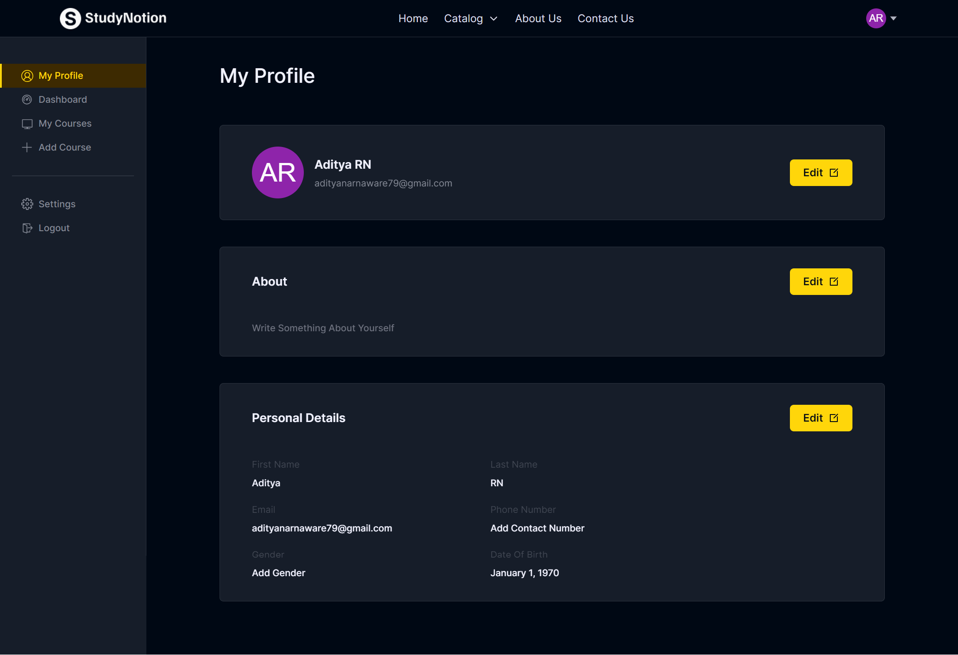

**3.10 Add Course Section**

import { useState } from "react";

import { useForm } from "react-hook-form";

import { toast } from "react-hot-toast";

import { IoAddCircleOutline } from "react-icons/io5";

import { MdNavigateNext } from "react-icons/md";

import { useDispatch, useSelector } from "react-redux";

import {

  createSection,

  updateSection,

} from "../../../../../services/operations/courseDetailsAPI";

import {

  setCourse,

  setEditCourse,

  setStep,

} from "../../../../../slices/courseSlice";

import IconBtn from "../../../../common/IconBtn";

import NestedView from "./NestedView";

export default function CourseBuilderForm() {

  const {

    register,

    handleSubmit,

    setValue,

    formState: { errors },

  } = useForm();

  const { course } = useSelector((state) => state.course);

  const { token } = useSelector((state) => state.auth);

  const [loading, setLoading] = useState(false);

  const [editSectionName, setEditSectionName] = useState(null);

  const dispatch = useDispatch();

  // handle form submission

  const onSubmit = async (data) => {

    // console.log(data)

    setLoading(true);

    let result;

    if (editSectionName) {

      result = await updateSection(

        {

          sectionName: data.sectionName,

          sectionId: editSectionName,

          courseId: course._id,

        },

        token

      );

      // console.log("edit", result)

    } else {

      result = await createSection(

        {

          sectionName: data.sectionName,

          courseId: course._id,

        },

        token

      );

    }

    if (result) {

      // console.log("section result", result)

      dispatch(setCourse(result));

      setEditSectionName(null);

      setValue("sectionName", "");

    }

    setLoading(false);

  };

  const cancelEdit = () => {

    setEditSectionName(null);

    setValue("sectionName", "");

  };

  const handleChangeEditSectionName = (sectionId, sectionName) => {

    if (editSectionName === sectionId) {

      cancelEdit();

      return;

    }

    setEditSectionName(sectionId);

    setValue("sectionName", sectionName);

  };

  const goToNext = () => {

    if (course.courseContent.length === 0) {

      toast.error("Please add atleast one section");

      return;

    }

    if (

      course.courseContent.some((section) => section.subSection.length === 0)

    ) {

      toast.error("Please add atleast one lecture in each section");

      return;

    }

    dispatch(setStep(3));

  };

  const goBack = () => {

    dispatch(setStep(1));

    dispatch(setEditCourse(true));

  };

  return (

    <div className="space-y-8 rounded-md border-[1px] border-richblack-700 bg-richblack-800 p-6">

      <p className="text-2xl font-semibold text-richblack-5">Course Builder</p>

      <form onSubmit={handleSubmit(onSubmit)} className="space-y-4">

        <div className="flex flex-col space-y-2">

          <label className="text-sm text-richblack-5" htmlFor="sectionName">

            Section Name <sup className="text-pink-200">*</sup>

          </label>

          <input

            id="sectionName"

            disabled={loading}

            placeholder="Add a section to build your course"

            {...register("sectionName", { required: true })}

            className="form-style w-full"

          />

          {errors.sectionName && (

            <span className="ml-2 text-xs tracking-wide text-pink-200">

              Section name is required

            </span>

          )}

        </div>

        <div className="flex items-end gap-x-4">

          <IconBtn

            type="submit"

            disabled={loading}

            text={editSectionName ? "Edit Section Name" : "Create Section"}

            outline={true}

          >

            <IoAddCircleOutline size={20} className="text-yellow-50" />

          </IconBtn>

          {editSectionName && (

            <button

              type="button"

              onClick={cancelEdit}

              className="text-sm text-richblack-300 underline"

            >

              Cancel Edit

            </button>

          )}

        </div>

      </form>

      {course.courseContent.length > 0 && (

        <NestedView handleChangeEditSectionName={handleChangeEditSectionName} />

      )}

      {/* Next Prev Button */}

      <div className="flex justify-end gap-x-3">

        <button

          onClick={goBack}

          className={`flex cursor-pointer items-center gap-x-2 rounded-md bg-richblack-300 py-[8px] px-[20px] font-semibold text-richblack-900`}

        >

          Back

        </button>

        <IconBtn disabled={loading} text="Next" onclick={goToNext}>

          <MdNavigateNext />

        </IconBtn>

      </div>

    </div>

  );

}

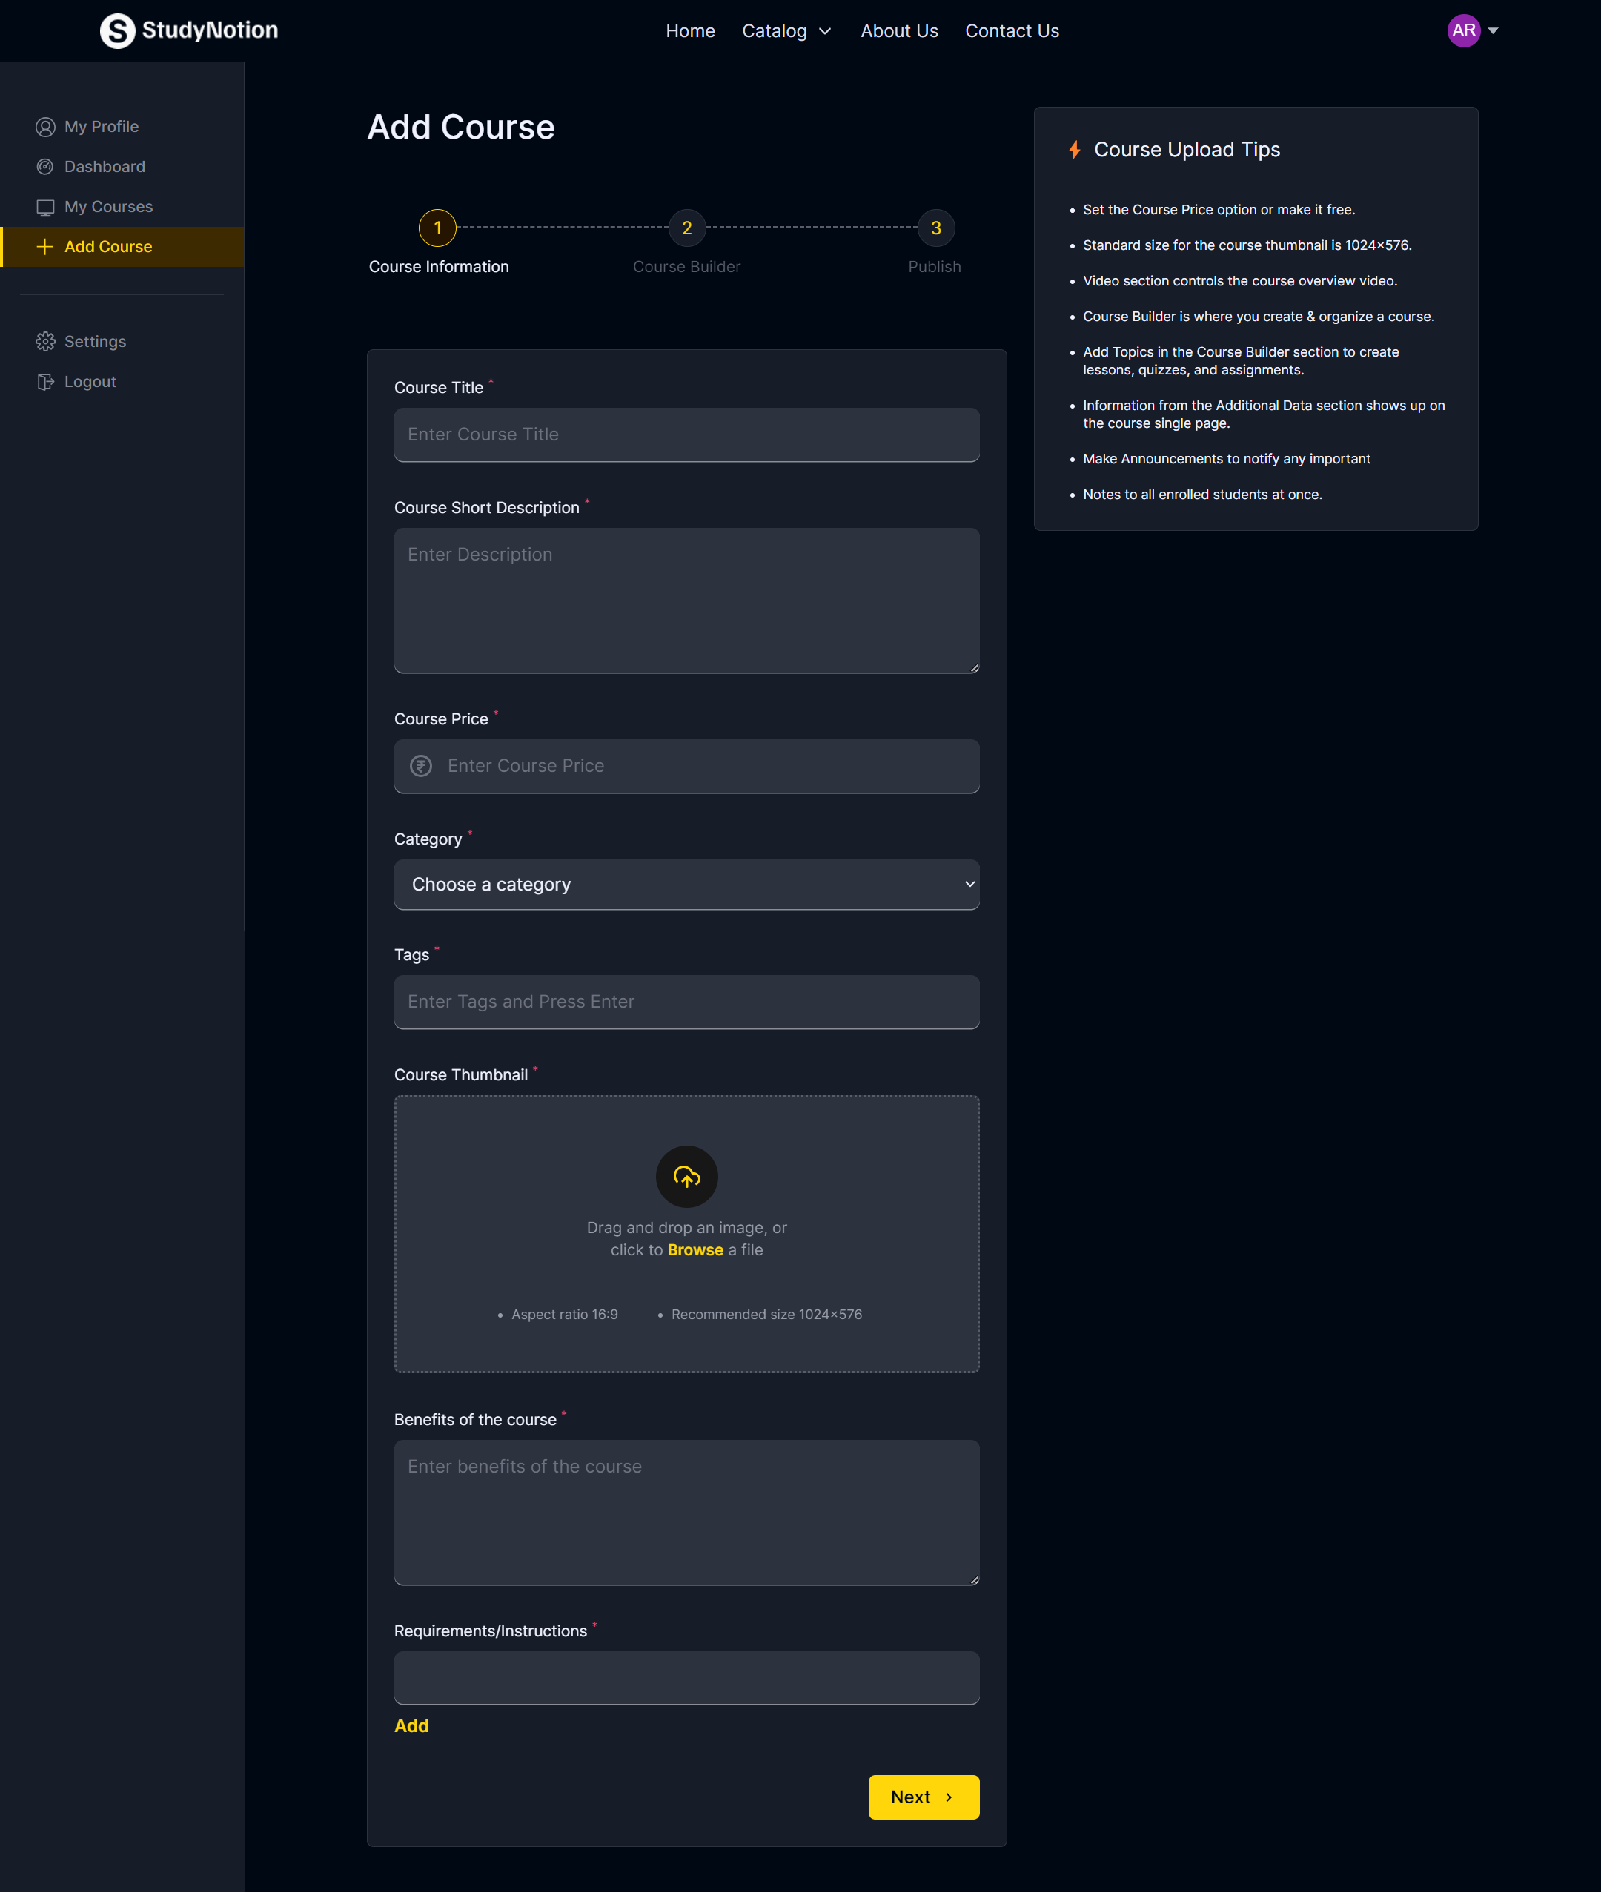

**3.11 Edit Profile Section**

import { toast } from "react-hot-toast";

import { setLoading, setUser } from "../../slices/profileSlice";

import { apiConnector } from "../apiconnector";

import { profileEndpoints } from "../apis";

import { logout } from "./authAPI";

const {

  GET_USER_DETAILS_API,

  GET_USER_ENROLLED_COURSES_API,

  GET_INSTRUCTOR_DATA_API,

} = profileEndpoints;

export function getUserDetails(token, navigate) {

  return async (dispatch) => {

    const toastId = toast.loading("Loading...");

    dispatch(setLoading(true));

    try {

      const response = await apiConnector("GET", GET_USER_DETAILS_API, null, {

        Authorization: `Bearer ${token}`,

      });

      console.log("GET_USER_DETAILS API RESPONSE............", response);

      if (!response.data.success) {

        throw new Error(response.data.message);

      }

      const userImage = response.data.data.image

        ? response.data.data.image

        : `https://api.dicebear.com/5.x/initials/svg?seed=${response.data.data.firstName} ${response.data.data.lastName}`;

      dispatch(setUser({ ...response.data.data, image: userImage }));

    } catch (error) {

      dispatch(logout(navigate));

      console.log("GET_USER_DETAILS API ERROR............", error);

      toast.error("Could Not Get User Details");

    }

    toast.dismiss(toastId);

    dispatch(setLoading(false));

  };

}

export async function getUserEnrolledCourses(token) {

  const toastId = toast.loading("Loading...");

  let result = [];

  try {

    console.log("BEFORE Calling BACKEND API FOR ENROLLED COURSES");

    const response = await apiConnector(

      "GET",

      GET_USER_ENROLLED_COURSES_API,

      null,

      {

        Authorization: `Bearer ${token}`,

      }

    );

    console.log("AFTER Calling BACKEND API FOR ENROLLED COURSES");

    // console.log(

    //   "GET_USER_ENROLLED_COURSES_API API RESPONSE............",

    //   response

    // )

    if (!response.data.success) {

      throw new Error(response.data.message);

    }

    result = response.data.data;

    console.log("result enrolled courses api---->>", result);

  } catch (error) {

    console.log("GET_USER_ENROLLED_COURSES_API API ERROR............", error);

    toast.error("Could Not Get Enrolled Courses");

  }

  toast.dismiss(toastId);

  return result;

}

export async function getInstructorData(token) {

  console.log("Before from profileApi token ----->", token);

  const toastId = toast.loading("Loading...");

  let result = [];

  try {

    const response = await apiConnector("GET", GET_INSTRUCTOR_DATA_API, null, {

      Authorization: `Bearer ${token}`,

    });

    console.log("GET_INSTRUCTOR_API_RESPONSE", response);

    console.log("After from profileApi token ----->", token);

    result = response?.data?.courses;

  } catch (error) {

    console.log("GET_INSTRUCTOR_API ERROR", error);

    toast.error("Could not Get Instructor Data");

  }

  toast.dismiss(toastId);

  return result;

}

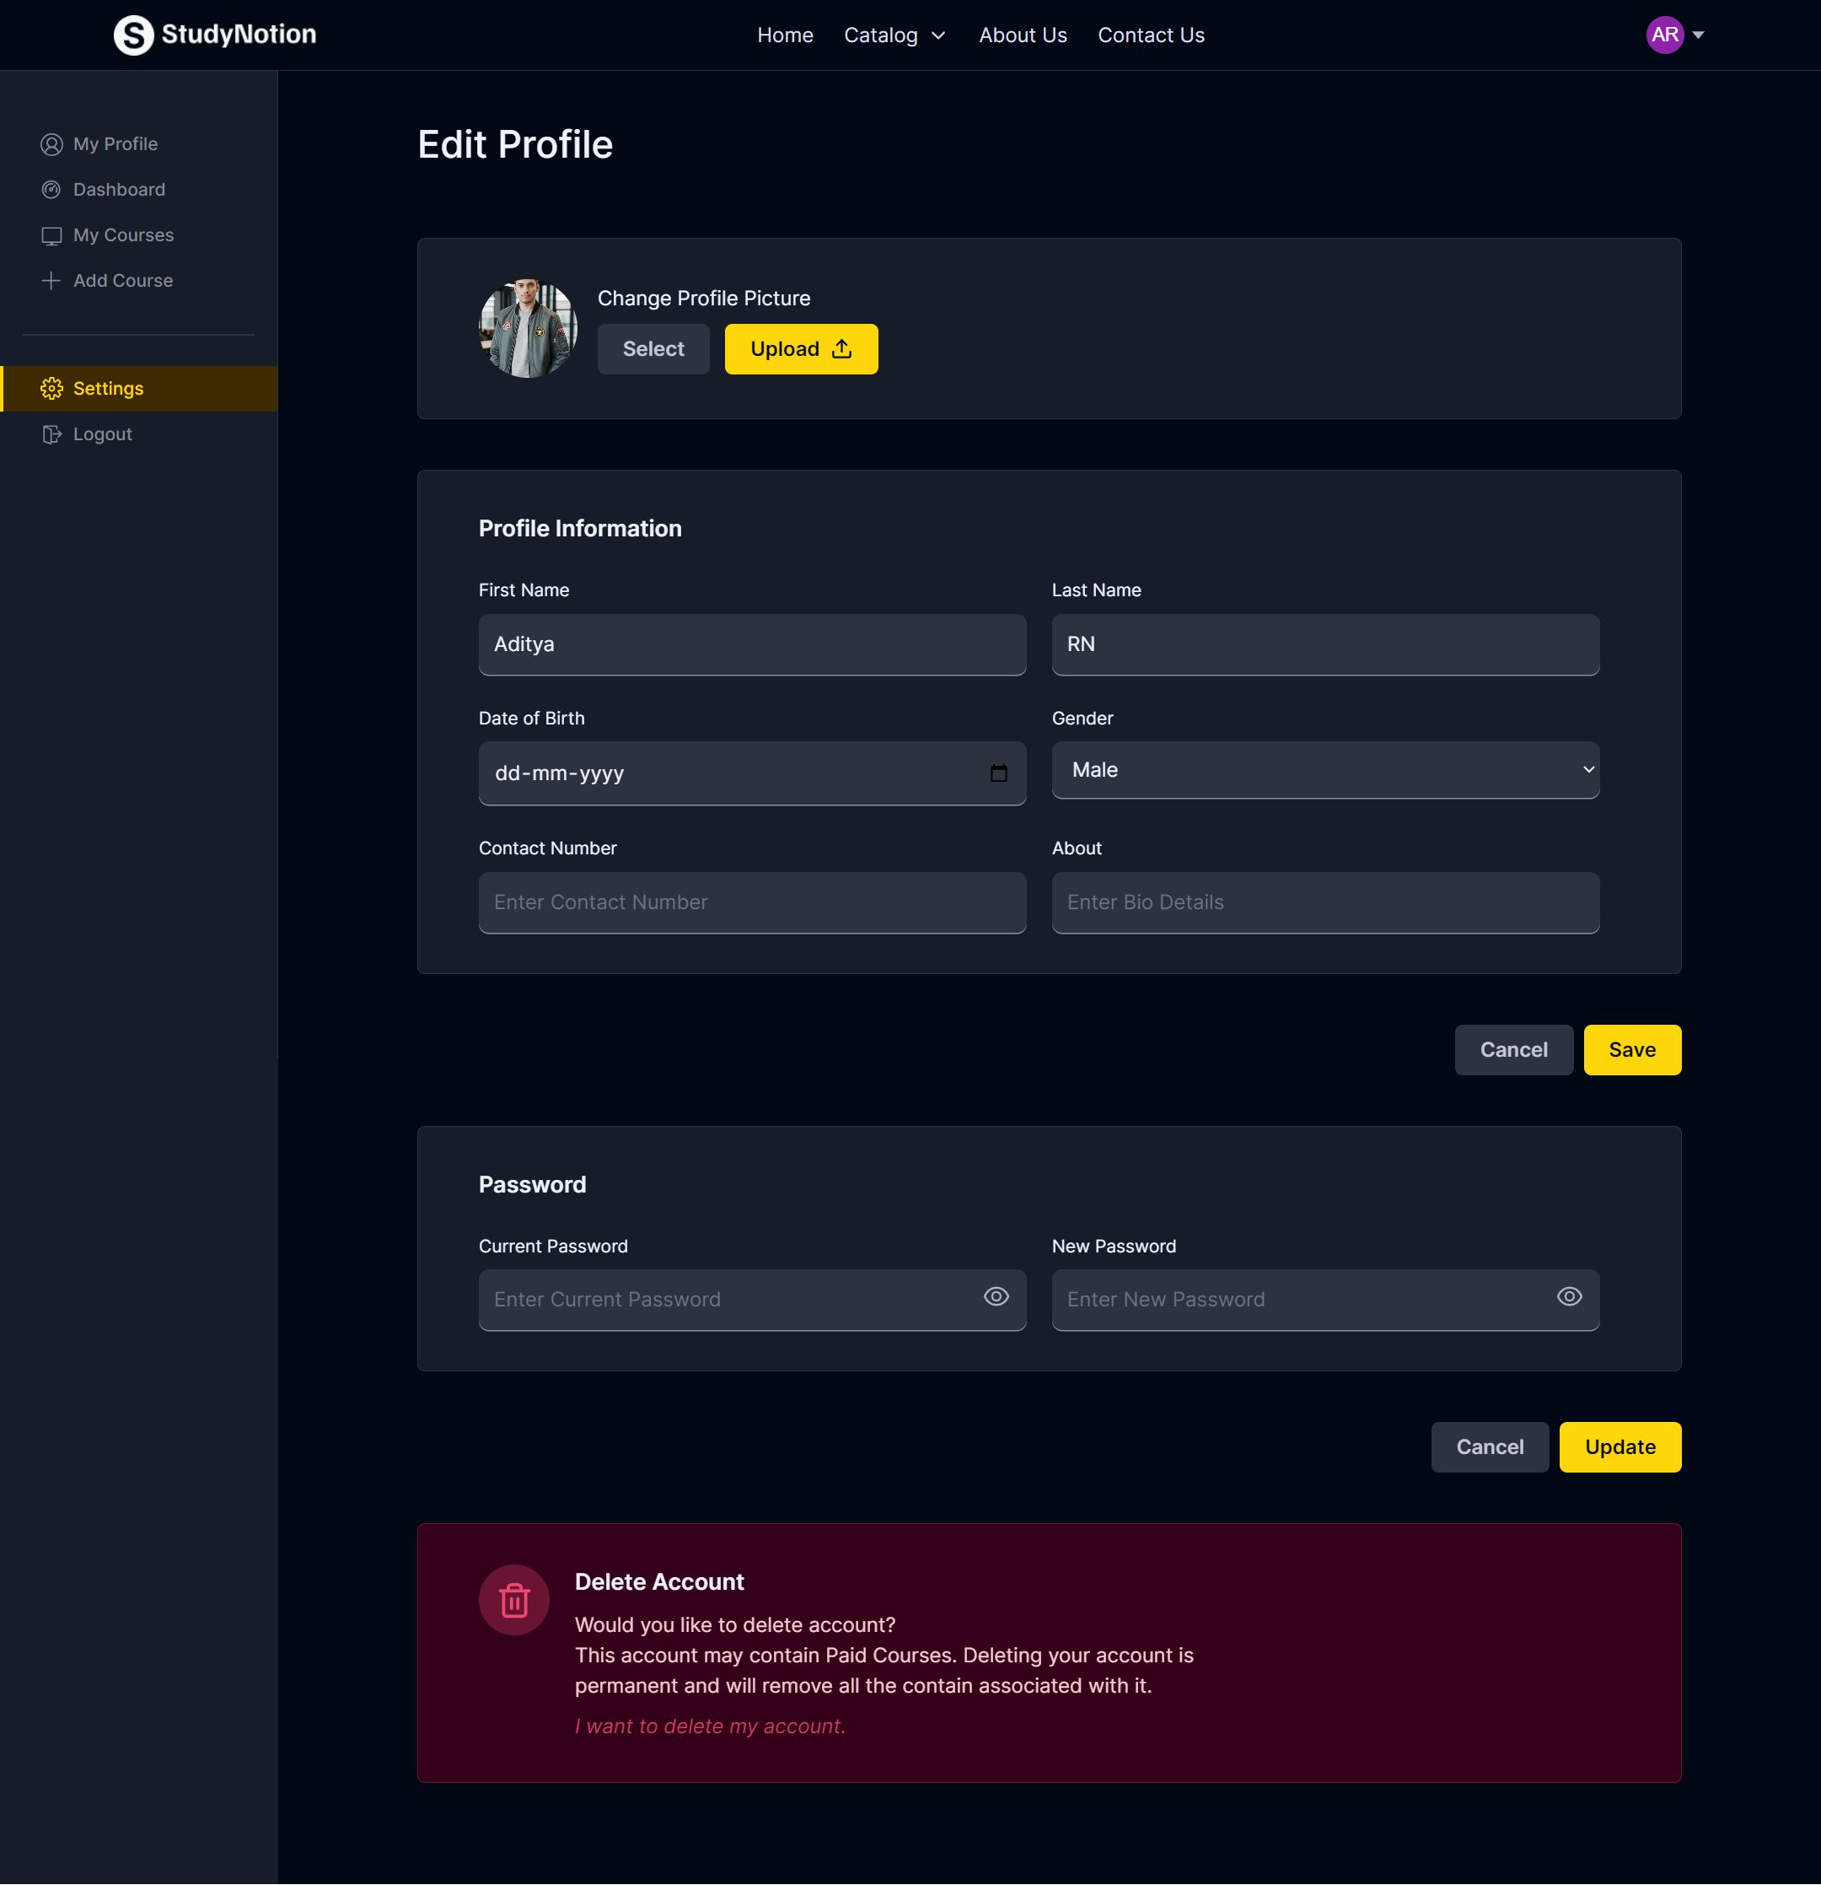

**3.12 DevOps Course List**

import {  useSelector } from "react-redux"

import { Table, Tbody, Td, Th, Thead, Tr } from "react-super-responsive-table"

// import { setCourse, setEditCourse } from "../../../../slices/courseSlice"

import "react-super-responsive-table/dist/SuperResponsiveTableStyle.css"

import { useState } from "react"

import { FaCheck } from "react-icons/fa"

import { FiEdit2 } from "react-icons/fi"

import { HiClock } from "react-icons/hi"

import { RiDeleteBin6Line } from "react-icons/ri"

import { useNavigate } from "react-router-dom"

import { formatDate } from "../../../../services/formatDate"

import {

  deleteCourse,

  fetchInstructorCourses,

} from "../../../../services/operations/courseDetailsAPI"

import { COURSE_STATUS } from "../../../../utils/constants"

import ConfirmationModal from "../../../common/ConfirmationModal"

export default function CoursesTable({ courses, setCourses }) {

  // const dispatch = useDispatch()

  const navigate = useNavigate()

  const { token } = useSelector((state) => state.auth)

  const [loading, setLoading] = useState(false)

  const [confirmationModal, setConfirmationModal] = useState(null)

  const TRUNCATE_LENGTH = 30

  const handleCourseDelete = async (courseId) => {

    setLoading(true)

    await deleteCourse({ courseId: courseId }, token)

    const result = await fetchInstructorCourses(token)

    if (result) {

      setCourses(result)

    }

    setConfirmationModal(null)

    setLoading(false)

  }

  // console.log("All Course ", courses)

  return (

    <>

      <Table className="rounded-xl border border-richblack-800 ">

        <Thead>

          <Tr className="flex gap-x-10 rounded-t-md border-b border-b-richblack-800 px-6 py-2">

            <Th className="flex-1 text-left text-sm font-medium uppercase text-richblack-100">

              Courses

            </Th>

            <Th className="text-left text-sm font-medium uppercase text-richblack-100">

              Duration

            </Th>

            <Th className="text-left text-sm font-medium uppercase text-richblack-100">

              Price

            </Th>

            <Th className="text-left text-sm font-medium uppercase text-richblack-100">

              Actions

            </Th>

          </Tr>

        </Thead>

        <Tbody>

          {courses?.length === 0 ? (

            <Tr>

              <Td className="py-10 text-center text-2xl font-medium text-richblack-100">

                No courses found

                {/* TODO: Need to change this state */}

              </Td>

            </Tr>

          ) : (

            courses?.map((course) => (

              <Tr

                key={course._id}

                className="flex gap-x-10 border-b border-richblack-800 px-6 py-8"

              >

                <Td className="flex flex-1 gap-x-4">

                  <img

                    src={course?.thumbnail}

                    alt={course?.courseName}

                    className="h-[148px] w-[220px] rounded-lg object-cover"

                  />

                  <div className="flex flex-col justify-between">

                    <p className="text-lg font-semibold text-richblack-5">

                      {course.courseName}

                    </p>

                    <p className="text-xs text-richblack-300">

                      {course.courseDescription.split(" ").length >

                      TRUNCATE_LENGTH

                        ? course.courseDescription

                            .split(" ")

                            .slice(0, TRUNCATE_LENGTH)

                            .join(" ") + "..."

                        : course.courseDescription}

                    </p>

                    <p className="text-[12px] text-white">

                      Created: {formatDate(course.createdAt)}

                    </p>

                    {course.status === COURSE_STATUS.DRAFT ? (

                      <p className="flex w-fit flex-row items-center gap-2 rounded-full bg-richblack-700 px-2 py-[2px] text-[12px] font-medium text-pink-100">

                        <HiClock size={14} />

                        Drafted

                      </p>

                    ) : (

                      <p className="flex w-fit flex-row items-center gap-2 rounded-full bg-richblack-700 px-2 py-[2px] text-[12px] font-medium text-yellow-100">

                        <div className="flex h-3 w-3 items-center justify-center rounded-full bg-yellow-100 text-richblack-700">

                          <FaCheck size={8} />

                        </div>

                        Published

                      </p>

                    )}

                  </div>

                </Td>

                <Td className="text-sm font-medium text-richblack-100">

                  2hr 30min

                </Td>

                <Td className="text-sm font-medium text-richblack-100">

                  ₹{course.price}

                </Td>

                <Td className="text-sm font-medium text-richblack-100 ">

                  <button

                    disabled={loading}

                    onClick={() => {

                      navigate(`/dashboard/edit-course/${course._id}`)

                    }}

                    title="Edit"

                    className="px-2 transition-all duration-200 hover:scale-110 hover:text-caribbeangreen-300"

                  >

                    <FiEdit2 size={20} />

                  </button>

                  <button

                    disabled={loading}

                    onClick={() => {

                      setConfirmationModal({

                        text1: "Do you want to delete this course?",

                        text2:

                          "All the data related to this course will be deleted",

                        btn1Text: !loading ? "Delete" : "Loading...  ",

                        btn2Text: "Cancel",

                        btn1Handler: !loading

                          ? () => handleCourseDelete(course._id)

                          : () => {},

                        btn2Handler: !loading

                          ? () => setConfirmationModal(null)

                          : () => {},

                      })

                    }}

                    title="Delete"

                    className="px-1 transition-all duration-200 hover:scale-110 hover:text-[#ff0000]"

                  >

                    <RiDeleteBin6Line size={20} />

                  </button>

                </Td>

              </Tr>

            ))

          )}

        </Tbody>

      </Table>

      {confirmationModal && <ConfirmationModal modalData={confirmationModal} />}

    </>

  )

}

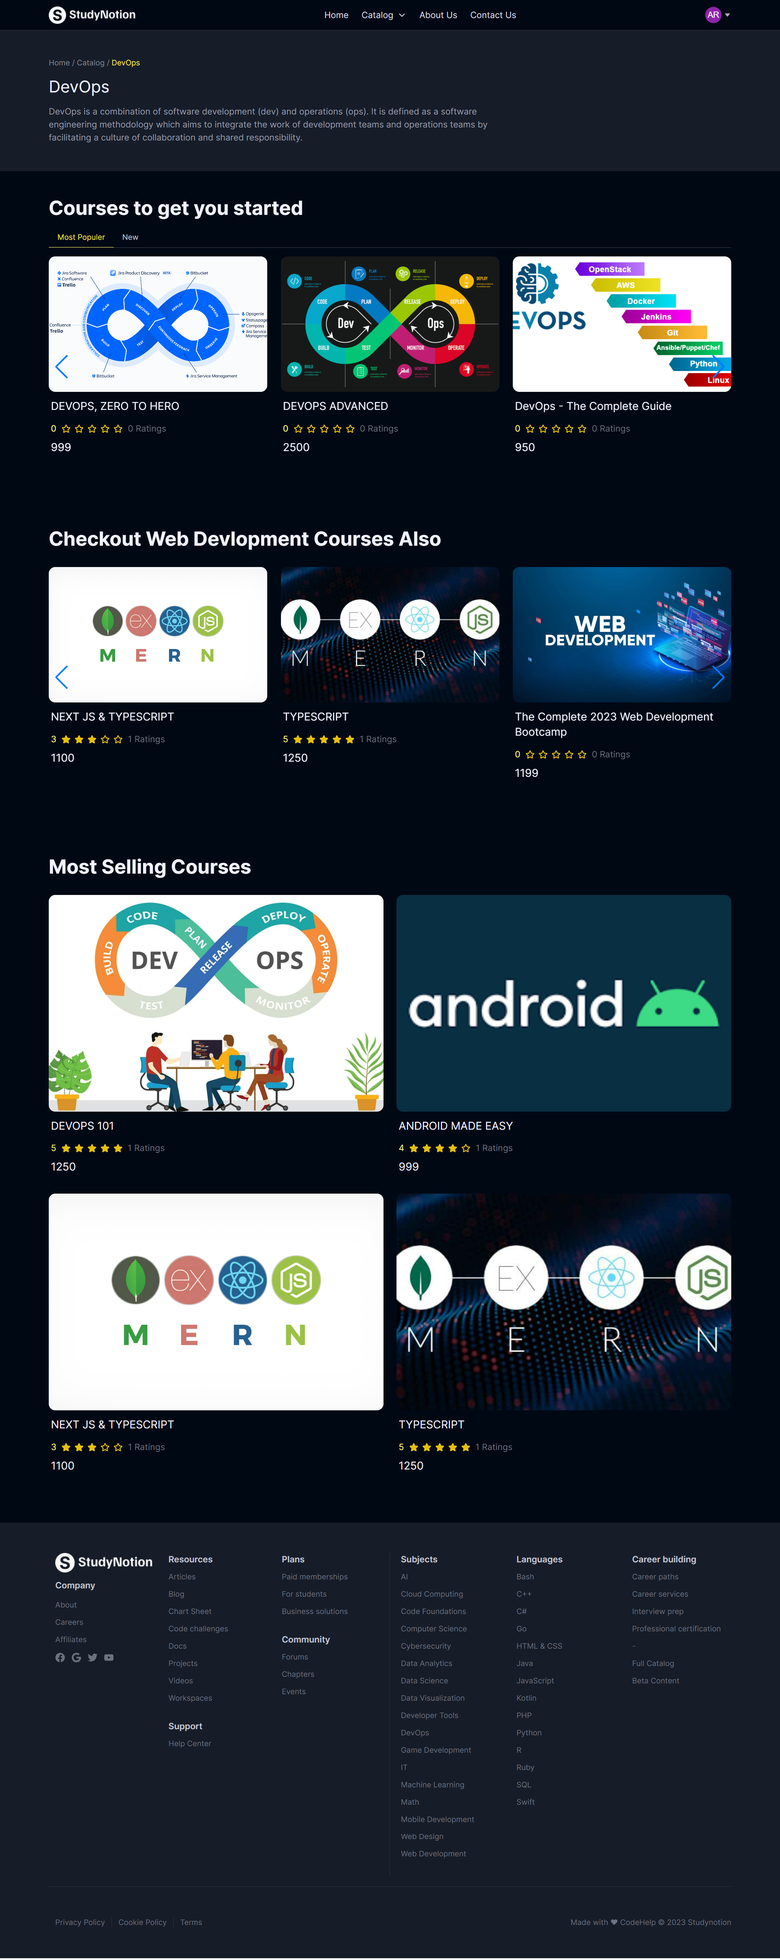

**3.13 Web Development Course List**

import React, { useEffect, useState } from "react";

import RatingStars from "../../common/RatingStars";

import GetAvgRating from "../../../utils/avgRating";

import { Link } from "react-router-dom";

const CourseCard = ({ course, Height }) => {

  const [avgReviewCount, setAvgReviewCount] = useState(0);

  useEffect(() => {

    const count = GetAvgRating(course.ratingAndReviews);

    setAvgReviewCount(count);

  }, [course]);

  return (

    <>

      <Link to={`/courses/${course._id}`}>

        <div className="">

          <div className="rounded-lg">

            <img

              src={course?.thumbnail}

              alt="course thumnail"

              className={`${Height} w-full rounded-xl object-cover `}

            />

          </div>

          <div className="flex flex-col gap-2 px-1 py-3">

            <p className="text-xl text-richblack-5">{course?.courseName}</p>

            <p className="text-sm text-richblack-50">

              {course?.instructor?.firstName} {course?.instructor?.lastName}

            </p>

            <div className="flex items-center gap-2">

              <span className="text-yellow-5">{avgReviewCount || 0}</span>

              <RatingStars Review_Count={avgReviewCount} />

              <span className="text-richblack-400">

                {course?.ratingAndReviews?.length} Ratings

              </span>

            </div>

            <p className="text-xl text-richblack-5">Rs. {course?.price}</p>

          </div>

        </div>

      </Link>

    </>

  );

};

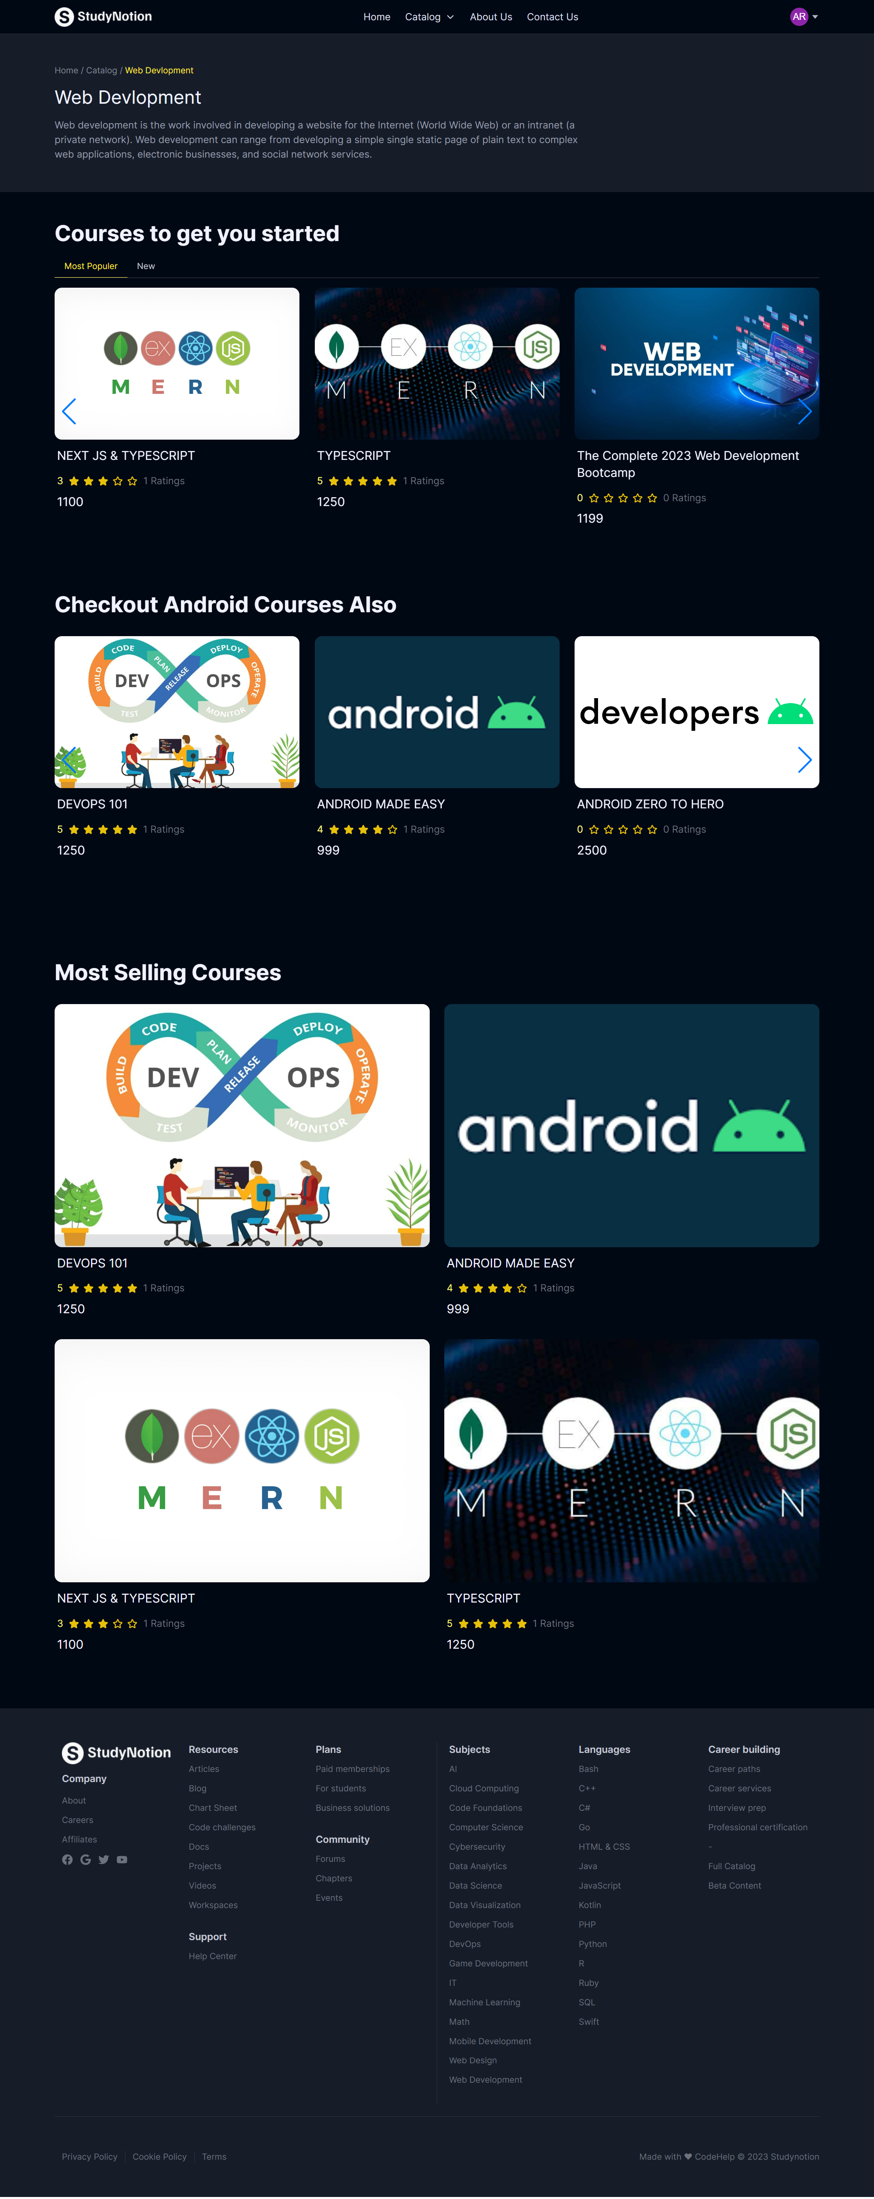

**3.14 Android Course List**

// Import the required modules

const express = require("express");

const router = express.Router();

// Import the Controllers

// Course Controllers Import

const {

  createCourse,

  getAllCourses,

  getCourseDetails,

  getFullCourseDetails,

  editCourse,

  getInstructorCourses,

  deleteCourse,

} = require("../controllers/Course");

// Categories Controllers Import

const {

  showAllCategories,

  createCategory,

  categoryPageDetails,

} = require("../controllers/Category");

// Sections Controllers Import

const {

  createSection,

  updateSection,

  deleteSection,

} = require("../controllers/Section");

// Sub-Sections Controllers Import

const {

  createSubSection,

  updateSubSection,

  deleteSubSection,

} = require("../controllers/Subsection");

// Rating Controllers Import

const {

  createRating,

  getAverageRating,

  getAllRating,

} = require("../controllers/RatingAndReview");

const { updateCourseProgress } = require("../controllers/courseProgress");

// Importing Middlewares

const {

  auth,

  isInstructor,

  isStudent,

  isAdmin,

} = require("../middlewares/auth");

// ********************************************************************************************************

//                                      Course routes

// ********************************************************************************************************

// Courses can Only be Created by Instructors

router.post("/createCourse", auth, isInstructor, createCourse);

//Add a Section to a Course

router.post("/addSection", auth, isInstructor, createSection);

// Update a Section

router.post("/updateSection", auth, isInstructor, updateSection);

// Delete a Section

router.post("/deleteSection", auth, isInstructor, deleteSection);

// Edit Sub Section

router.post("/updateSubSection", auth, isInstructor, updateSubSection);

// Delete Sub Section

router.post("/deleteSubSection", auth, isInstructor, deleteSubSection);

// Add a Sub Section to a Section

router.post("/addSubSection", auth, isInstructor, createSubSection);

// Get all Registered Courses

router.get("/getAllCourses", getAllCourses);

// Get Details for a Specific Courses

router.post("/getCourseDetails", getCourseDetails);

// Get Details for a Specific Courses

router.post("/getFullCourseDetails", auth, getFullCourseDetails);

// Edit Course routes

router.post("/editCourse", auth, isInstructor, editCourse);

// Get all Courses Under a Specific Instructor

router.get("/getInstructorCourses", auth, isInstructor, getInstructorCourses);

// Delete a Course

router.delete("/deleteCourse", deleteCourse);

router.post("/updateCourseProgress", auth, isStudent, updateCourseProgress);

// ********************************************************************************************************

//                                      Category routes (Only by Admin)

// ********************************************************************************************************

// Category can Only be Created by Admin

// TODO: Put IsAdmin Middleware here

router.post("/createCategory", auth, isAdmin, createCategory);

// router.get("/showAllCategories", showAllCategories);

router.post("/getCategoryPageDetails", categoryPageDetails);

// !before in showAllCategories when write "auth" this create the problem status code 401 not found

router.get("/showAllCategories", showAllCategories);

// ********************************************************************************************************

//                                      Rating and Review

// ********************************************************************************************************

router.post("/createRating", auth, isStudent, createRating);

router.get("/getAverageRating", getAverageRating);

router.get("/getReviews", getAllRating);

module.exports = router;

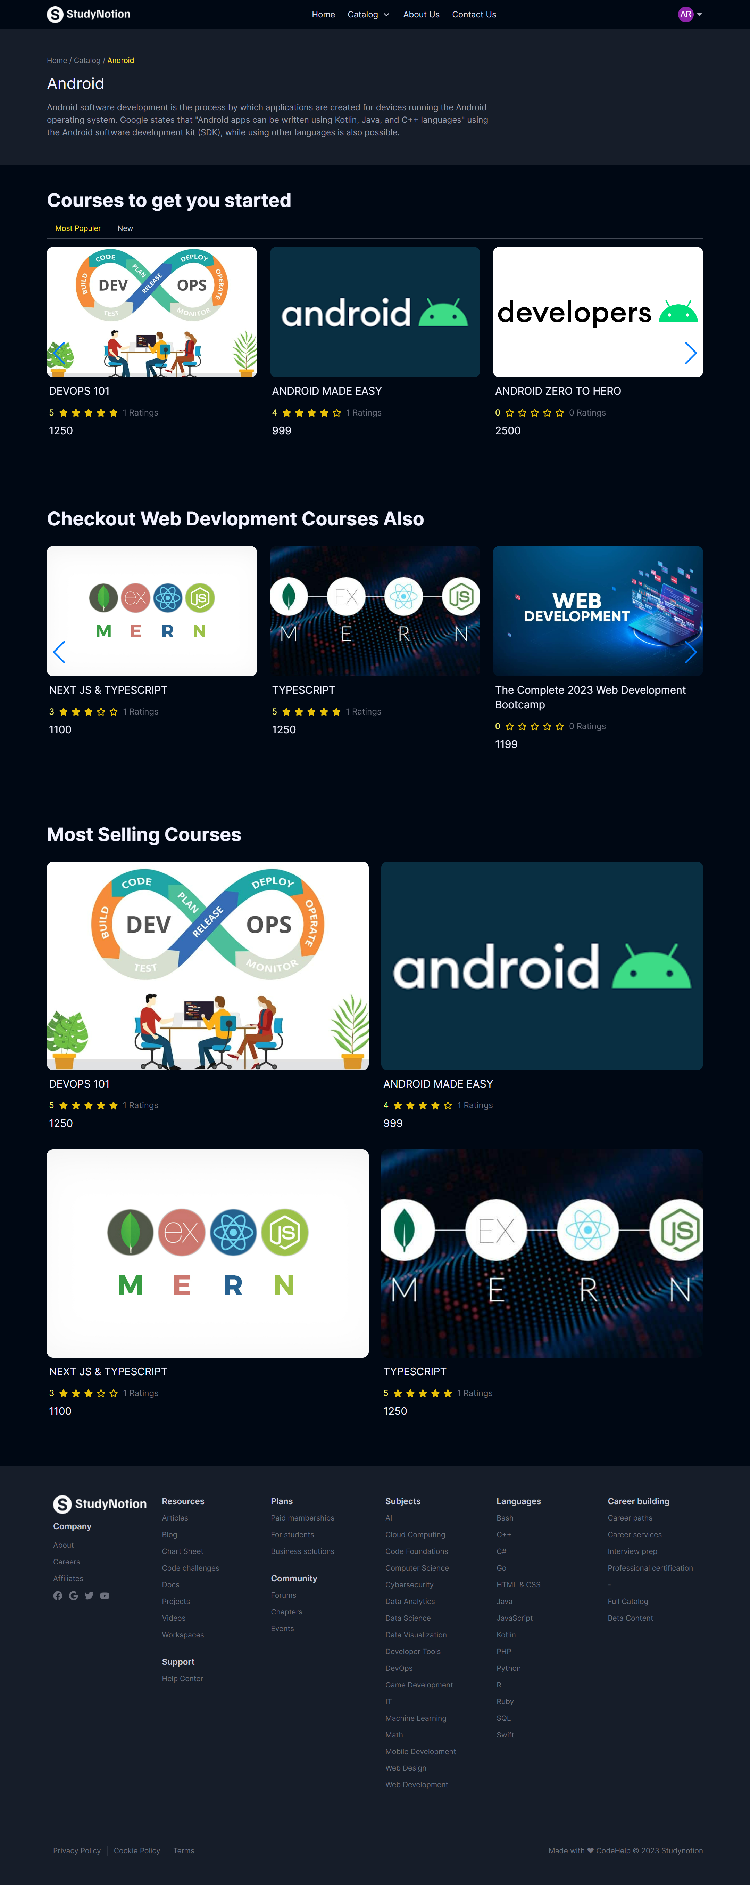

import React from "react";

import HighlightText from "../../../components/core/HomePage/HighlightText";

import CTAButton from "../../../components/core/HomePage/Button";

const LearningGridArray = [

  {

    order: -1,

    heading: "World-Class Learning for",

    highlightText: "Anyone, Anywhere",

    description:

      "Studynotion partners with more than 275+ leading universities and companies to bring flexible, affordable, job-relevant online learning to individuals and organizations worldwide.",

    BtnText: "Learn More",

    BtnLink: "/",

  },

  {

    order: 1,

    heading: "Curriculum Based on Industry Needs",

    description:

      "Save time and money! The Belajar curriculum is made to be easier to understand and in line with industry needs.",

  },

  {

    order: 2,

    heading: "Our Learning Methods",

    description:

      "Studynotion partners with more than 275+ leading universities and companies to bring",

  },

  {

    order: 3,

    heading: "Certification",

    description:

      "Studynotion partners with more than 275+ leading universities and companies to bring",

  },

  {

    order: 4,

    heading: `Rating "Auto-grading"`,

    description:

      "Studynotion partners with more than 275+ leading universities and companies to bring",

  },

  {

    order: 5,

    heading: "Ready to Work",

    description:

      "Studynotion partners with more than 275+ leading universities and companies to bring",

  },

];

const LearningGrid = () => {

  return (

    <div className="grid mx-auto w-[350px] xl:w-fit grid-cols-1 xl:grid-cols-4 mb-12">

      {LearningGridArray.map((card, i) => {

        return (

          <div

            key={i}

            className={`${i === 0 && "xl:col-span-2 xl:h-[294px]"}  ${

              card.order % 2 === 1

                ? "bg-richblack-700 h-[294px]"

                : card.order % 2 === 0

                ? "bg-richblack-800 h-[294px]"

                : "bg-transparent"

            } ${card.order === 3 && "xl:col-start-2"}  `}

          >

            {card.order < 0 ? (

              <div className="xl:w-[90%] flex flex-col gap-3 pb-10 xl:pb-0">

                <div className="text-4xl font-semibold ">

                  {card.heading}

                  <HighlightText text={card.highlightText} />

                </div>

                <p className="text-richblack-300 font-medium">

                  {card.description}

                </p>

                <div className="w-fit mt-2">

                  <CTAButton active={true} linkto={card.BtnLink}>

                    {card.BtnText}

                  </CTAButton>

                </div>

              </div>

            ) : (

              <div className="p-8 flex flex-col gap-8">

                <h1 className="text-richblack-5 text-lg">{card.heading}</h1>

                <p className="text-richblack-300 font-medium">

                  {card.description}

                </p>

              </div>

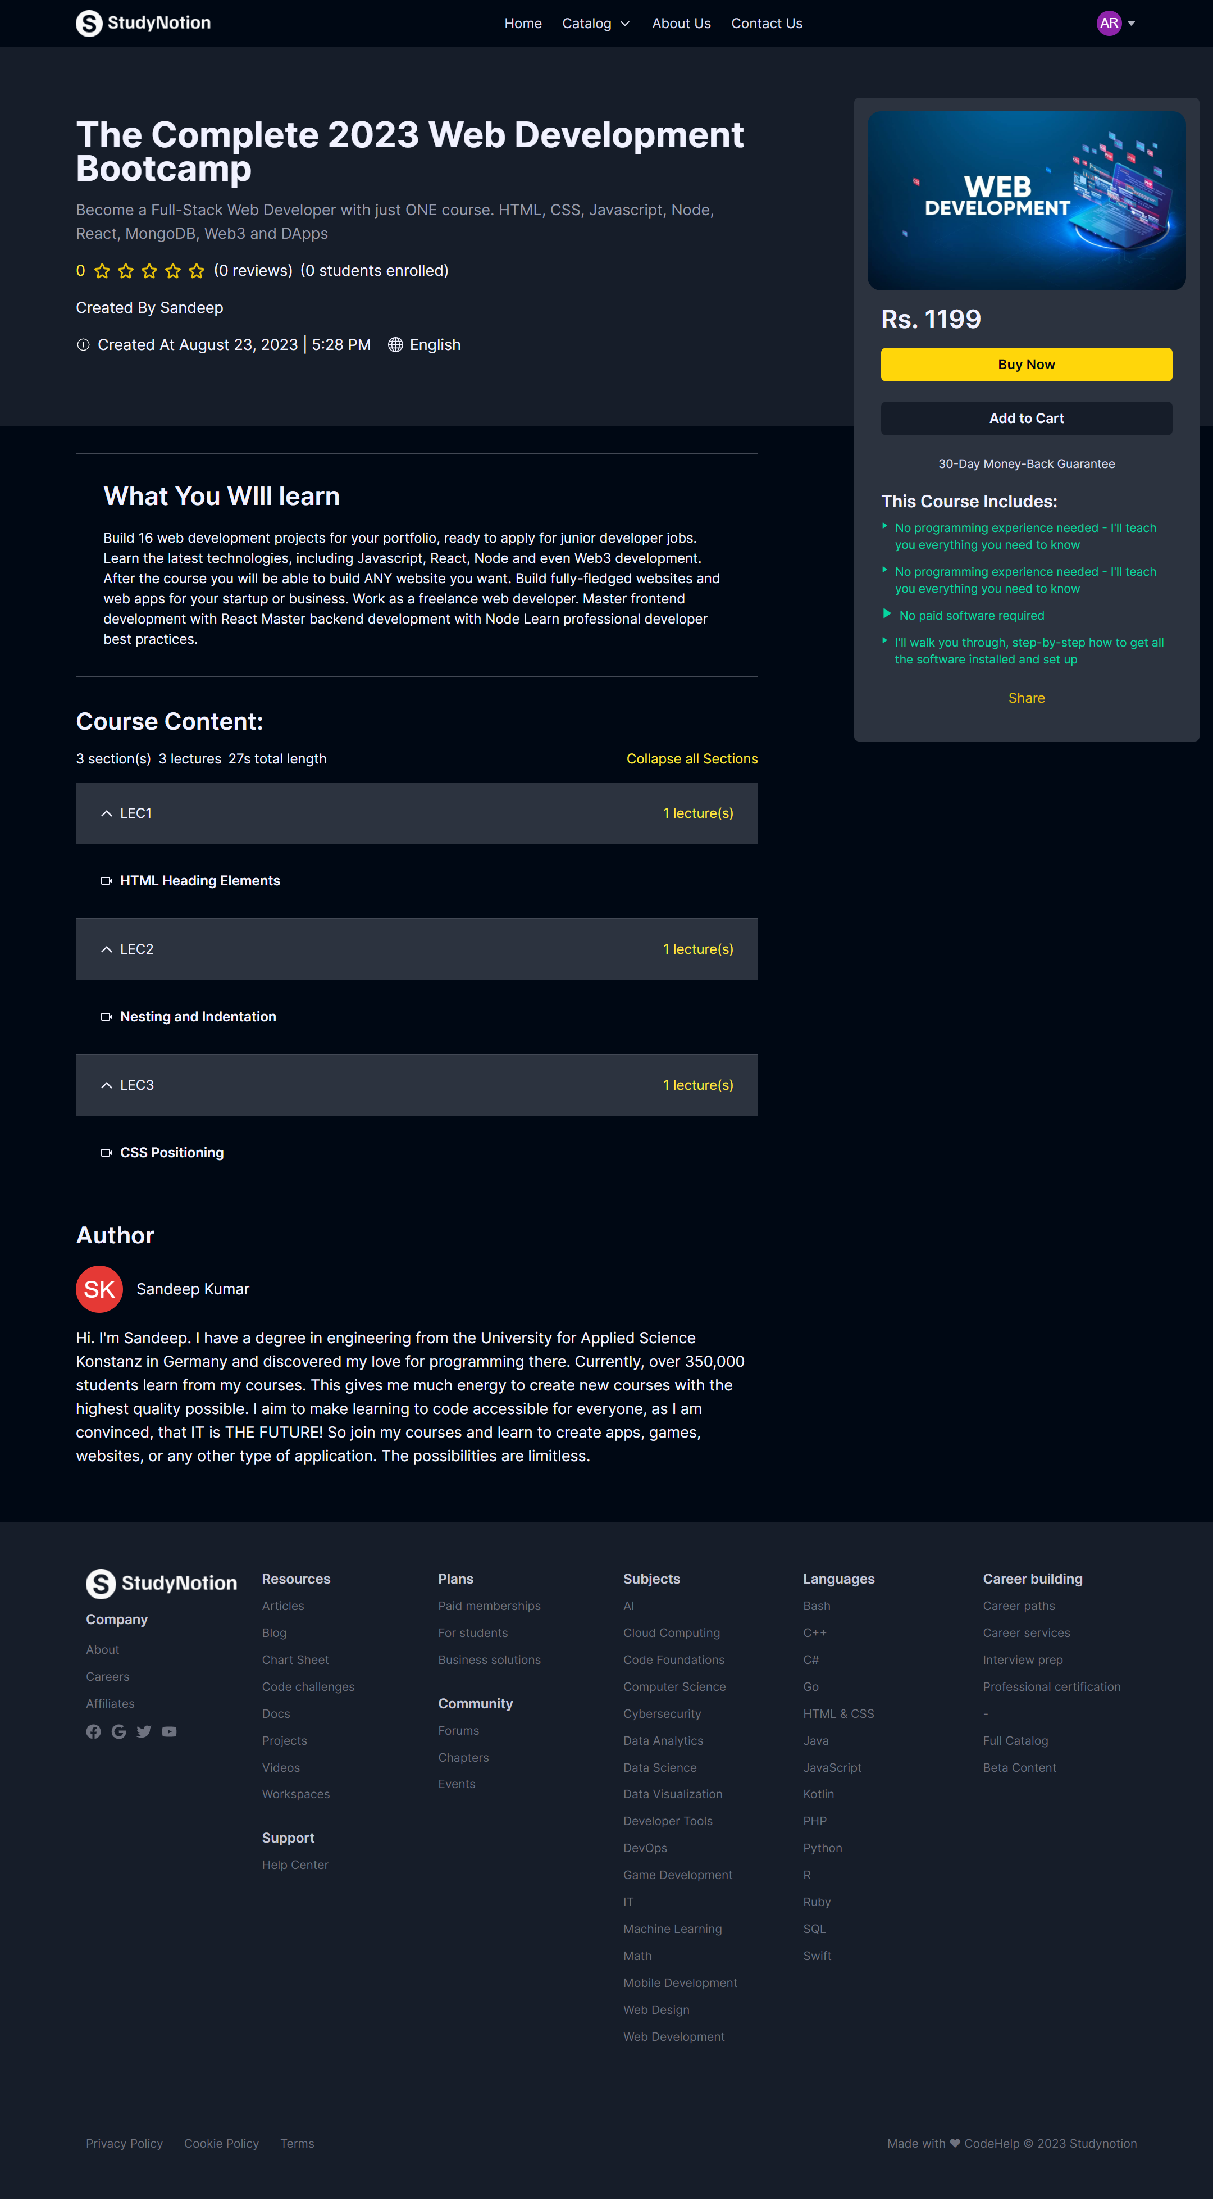

**3.13 About Us Page**

import React from "react";

import HighlightText from "../../../components/core/HomePage/HighlightText";

import CTAButton from "../../../components/core/HomePage/Button";

const LearningGridArray = [

  {

    order: -1,

    heading: "World-Class Learning for",

    highlightText: "Anyone, Anywhere",

    description:

      "Studynotion partners with more than 275+ leading universities and companies to bring flexible, affordable, job-relevant online learning to individuals and organizations worldwide.",

    BtnText: "Learn More",

    BtnLink: "/",

  },

  {

    order: 1,

    heading: "Curriculum Based on Industry Needs",

    description:

      "Save time and money! The Belajar curriculum is made to be easier to understand and in line with industry needs.",

  },

  {

    order: 2,

    heading: "Our Learning Methods",

    description:

      "Studynotion partners with more than 275+ leading universities and companies to bring",

  },

  {

    order: 3,

    heading: "Certification",

    description:

      "Studynotion partners with more than 275+ leading universities and companies to bring",

  },

  {

    order: 4,

    heading: `Rating "Auto-grading"`,

    description:

      "Studynotion partners with more than 275+ leading universities and companies to bring",

  },

  {

    order: 5,

    heading: "Ready to Work",

    description:

      "Studynotion partners with more than 275+ leading universities and companies to bring",

  },

];

const LearningGrid = () => {

  return (

    <div className="grid mx-auto w-[350px] xl:w-fit grid-cols-1 xl:grid-cols-4 mb-12">

      {LearningGridArray.map((card, i) => {

        return (

          <div

            key={i}

            className={`${i === 0 && "xl:col-span-2 xl:h-[294px]"}  ${

              card.order % 2 === 1

                ? "bg-richblack-700 h-[294px]"

                : card.order % 2 === 0

                ? "bg-richblack-800 h-[294px]"

                : "bg-transparent"

            } ${card.order === 3 && "xl:col-start-2"}  `}

          >

            {card.order < 0 ? (

              <div className="xl:w-[90%] flex flex-col gap-3 pb-10 xl:pb-0">

                <div className="text-4xl font-semibold ">

                  {card.heading}

                  <HighlightText text={card.highlightText} />

                </div>

                <p className="text-richblack-300 font-medium">

                  {card.description}

                </p>

                <div className="w-fit mt-2">

                  <CTAButton active={true} linkto={card.BtnLink}>

                    {card.BtnText}

                  </CTAButton>

                </div>

              </div>

            ) : (

              <div className="p-8 flex flex-col gap-8">

                <h1 className="text-richblack-5 text-lg">{card.heading}</h1>

                <p className="text-richblack-300 font-medium">

                  {card.description}

                </p>

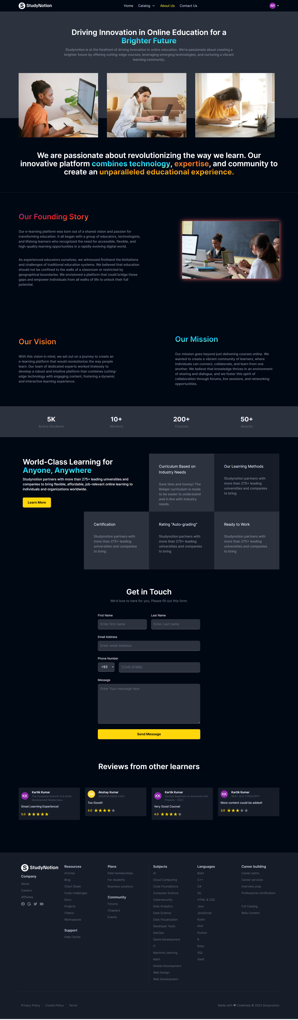

**3.14 Contact us Section**

import React from "react"

import Footer from "../components/common/Footer"

import ContactDetails from "../components/ContactPage/ContactDetails"

import ContactForm from "../components/ContactPage/ContactForm"

import ReviewSlider from "../components/common/ReviewSlider"

const Contact = () => {

  return (

    <div>

      <div className="mx-auto mt-20 flex w-11/12 max-w-maxContent flex-col justify-between gap-10 text-white lg:flex-row">

        {/* Contact Details */}

        <div className="lg:w-[40%]">

          <ContactDetails />

        </div>

        {/* Contact Form */}

        <div className="lg:w-[60%]">

          <ContactForm />

        </div>

      </div>

      <div className="relative mx-auto my-20 flex w-11/12 max-w-maxContent flex-col items-center justify-between gap-8 bg-richblack-900 text-white">

        {/* Reviws from Other Learner */}

        <h1 className="text-center text-4xl font-semibold mt-8">

          Reviews from other learners

        </h1>

        <ReviewSlider />

      </div>

      <Footer />

    </div>

  )

}

export default Contact

import React, { useEffect, useState } from "react";

import { BiInfoCircle } from "react-icons/bi";

import { HiOutlineGlobeAlt } from "react-icons/hi";

import { ReactMarkdown } from "react-markdown/lib/react-markdown";

import { useDispatch, useSelector } from "react-redux";

import { useNavigate, useParams } from "react-router-dom";

import ConfirmationModal from "../components/common/ConfirmationModal";

import Footer from "../components/common/Footer";

import RatingStars from "../components/common/RatingStars";

import CourseAccordionBar from "../components/core/Course/CourseAccordionBar";

import CourseDetailsCard from "../components/core/Course/CourseDetailsCard";

import { formatDate } from "../services/formatDate";

import { fetchCourseDetails } from "../services/operations/courseDetailsAPI";

import { buyCourse } from "../services/operations/studentFeaturesAPI";

import GetAvgRating from "../utils/avgRating";

import Error from "./Error";

function CourseDetails() {

  const { user } = useSelector((state) => state.profile);

  const { token } = useSelector((state) => state.auth);

  const { loading } = useSelector((state) => state.profile);

  const { paymentLoading } = useSelector((state) => state.course);

  const dispatch = useDispatch();

  const navigate = useNavigate();

  // Getting courseId from url parameter

  const { courseId } = useParams();

  // console.log(`course id: ${courseId}`)

  console.log("useParams------->>>>>>", courseId);

  // Declear a state to save the course details

  const [response, setResponse] = useState(null);

  const [confirmationModal, setConfirmationModal] = useState(null);

  useEffect(() => {

    // Calling fetchCourseDetails fucntion to fetch the details

    (async () => {

      try {

        const res = await fetchCourseDetails(courseId);

        setResponse(res);

      } catch (error) {

        console.log("Could not fetch Course Details");

      }

    })();

  }, [courseId]);

  // Calculating Avg Review count

  const [avgReviewCount, setAvgReviewCount] = useState(0);

  useEffect(() => {

    const count = GetAvgRating(response?.data?.courseDetails.ratingAndReviews);

    setAvgReviewCount(count);

  }, [response]);

  // console.log("avgReviewCount: ", avgReviewCount)

  // // Collapse all

  // const [collapse, setCollapse] = useState("")

  const [isActive, setIsActive] = useState(Array(0));

  const handleActive = (id) => {

    // console.log("called", id)

    setIsActive(

      !isActive.includes(id)

        ? isActive.concat([id])

        : isActive.filter((e) => e !== id)

    );

  };

  // Total number of lectures

  const [totalNoOfLectures, setTotalNoOfLectures] = useState(0);

  useEffect(() => {

    let lectures = 0;

    response?.data?.courseDetails?.courseContent?.forEach((sec) => {

      lectures += sec.subSection.length || 0;

    });

    setTotalNoOfLectures(lectures);

  }, [response]);

  if (loading || !response) {

    return (

      <div className="grid min-h-[calc(100vh-3.5rem)] place-items-center">

        <div className="spinner"></div>

      </div>

    );

  }

  if (!response.success) {

    return <Error />;

  }

  const {

    // _id: course_id,

    courseName,

    courseDescription,

    thumbnail,

    price,

    whatYouWillLearn,

    courseContent,

    ratingAndReviews,

    instructor,

    studentsEnrolled,

    createdAt,

  } = response.data?.courseDetails;

  // console.log(

  //   "response.data?.courseDetails--&&&&&&&&&&&&&&&7-->",

  //   response.data?.courseDetails

  // );

  // console.log(" _id: course_id,-----kkkkk--..", course_id);

  const handleBuyCourse = () => {

    if (token) {

      console.log("handleBuyCourse ---> token", token);

      console.log("handleBuyCourse ---> courseId", [courseId]);

      console.log("handleBuyCourse ---> user", user);

      buyCourse(token, [courseId], user, navigate, dispatch);

      return;

    }

    setConfirmationModal({

      text1: "You are not logged in!",

      text2: "Please login to Purchase Course.",

      btn1Text: "Login",

      btn2Text: "Cancel",

      btn1Handler: () => navigate("/login"),

      btn2Handler: () => setConfirmationModal(null),

    });

  };

  if (paymentLoading) {

    // console.log("payment loading")

    return (

      <div className="grid min-h-[calc(100vh-3.5rem)] place-items-center">

        <div className="spinner"></div>

      </div>

    );

  }

  return (

    <>

      <div className={`relative w-full bg-richblack-800`}>

        {/* Hero Section */}

        <div className="mx-auto box-content px-4 lg:w-[1260px] 2xl:relative ">

          <div className="mx-auto grid min-h-[450px] max-w-maxContentTab justify-items-center py-8 lg:mx-0 lg:justify-items-start lg:py-0 xl:max-w-[810px]">

            <div className="relative block max-h-[30rem] lg:hidden">

              <div className="absolute bottom-0 left-0 h-full w-full shadow-[#161D29_0px_-64px_36px_-28px_inset]"></div>

              <img

                src={thumbnail}

                alt="course thumbnail"

                className="aspect-auto w-full"

              />

            </div>

            <div

              className={`z-30 my-5 flex flex-col justify-center gap-4 py-5 text-lg text-richblack-5`}

            >

              <div>

                <p className="text-4xl font-bold text-richblack-5 sm:text-[42px]">

                  {courseName}

                </p>

              </div>

              <p className={`text-richblack-200`}>{courseDescription}</p>

              <div className="text-md flex flex-wrap items-center gap-2">

                <span className="text-yellow-25">{avgReviewCount}</span>

                <RatingStars Review_Count={avgReviewCount} Star_Size={24} />

                <span>{`(${ratingAndReviews.length} reviews)`}</span>

                <span>{`${studentsEnrolled.length} students enrolled`}</span>

              </div>

              <div>

                <p className="">

                  Created By{" "}

                  {`${instructor?.firstName} ${instructor?.lastName}`}

                </p>

              </div>

              <div className="flex flex-wrap gap-5 text-lg">

                <p className="flex items-center gap-2">

                  {" "}

                  <BiInfoCircle /> Created at {formatDate(createdAt)}

                </p>

                <p className="flex items-center gap-2">

                  {" "}

                  <HiOutlineGlobeAlt /> English

                </p>

              </div>

            </div>

            <div className="flex w-full flex-col gap-4 border-y border-y-richblack-500 py-4 lg:hidden">

              <p className="space-x-3 pb-4 text-3xl font-semibold text-richblack-5">

                Rs. {price}

              </p>

              <button

                className="yellowButton text-richblack-5 bg-richblack-600 px-3 py-1 w-fit rounded-md"

                onClick={handleBuyCourse}

              >

                Buy Now

              </button>

              <button className="blackButton px-3 py-1 w-fit rounded-md text-richblack-5 bg-richblack-600">

                Add to Cart

              </button>

            </div>

          </div>

          {/* Courses Card */}

          <div className="right-[1rem] top-[60px] mx-auto hidden min-h-[600px] w-1/3 max-w-[410px] translate-y-24 md:translate-y-0 lg:absolute  lg:block">

            <CourseDetailsCard

              course={response?.data?.courseDetails}

              setConfirmationModal={setConfirmationModal}

              handleBuyCourse={handleBuyCourse}

            />

          </div>

        </div>

      </div>

      <div className="mx-auto box-content px-4 text-start text-richblack-5 lg:w-[1260px]">

        <div className="mx-auto max-w-maxContentTab lg:mx-0 xl:max-w-[810px]">

          {/* What will you learn section */}

          <div className="my-8 border border-richblack-600 p-8">

            <p className="text-3xl font-semibold">What you'll learn</p>

            <div className="mt-5">

              <ReactMarkdown>{whatYouWillLearn}</ReactMarkdown>

            </div>

          </div>

          {/* Course Content Section */}

          <div className="max-w-[830px] ">

            <div className="flex flex-col gap-3">

              <p className="text-[28px] font-semibold">Course Content</p>

              <div className="flex flex-wrap justify-between gap-2">

                <div className="flex gap-2">

                  <span>

                    {courseContent.length} {`section(s)`}

                  </span>

                  <span>

                    {totalNoOfLectures} {`lecture(s)`}

                  </span>

                  <span>{response.data?.totalDuration} total length</span>

                </div>

                <div>

                  <button

                    className="text-yellow-25"

                    onClick={() => setIsActive([])}

                  >

                    Collapse all sections

                  </button>

                </div>

              </div>

            </div>

            {/* Course Details Accordion */}

            <div className="py-4">

              {courseContent?.map((course, index) => (

                <CourseAccordionBar

                  course={course}

                  key={index}

                  isActive={isActive}

                  handleActive={handleActive}

                />

              ))}

            </div>

            {/* Author Details */}

            <div className="mb-12 py-4">

              <p className="text-[28px] font-semibold">Author</p>

              <div className="flex items-center gap-4 py-4">

                <img

                  src={

                    instructor?.image

                      ? instructor?.image

                      : `https://api.dicebear.com/5.x/initials/svg?seed=${instructor?.firstName} ${instructor?.lastName}`

                  }

                  alt="Author"

                  className="h-14 w-14 rounded-full object-cover"

                />

                <p className="text-lg">{`${instructor?.firstName} ${instructor?.lastName}`}</p>

              </div>

              <p className="text-richblack-50">

                {instructor?.additionalDetails?.about}

              </p>

            </div>

          </div>

        </div>

      </div>

      <Footer />

      {confirmationModal && <ConfirmationModal modalData={confirmationModal} />}

    </>

  );

}

export default CourseDetails;

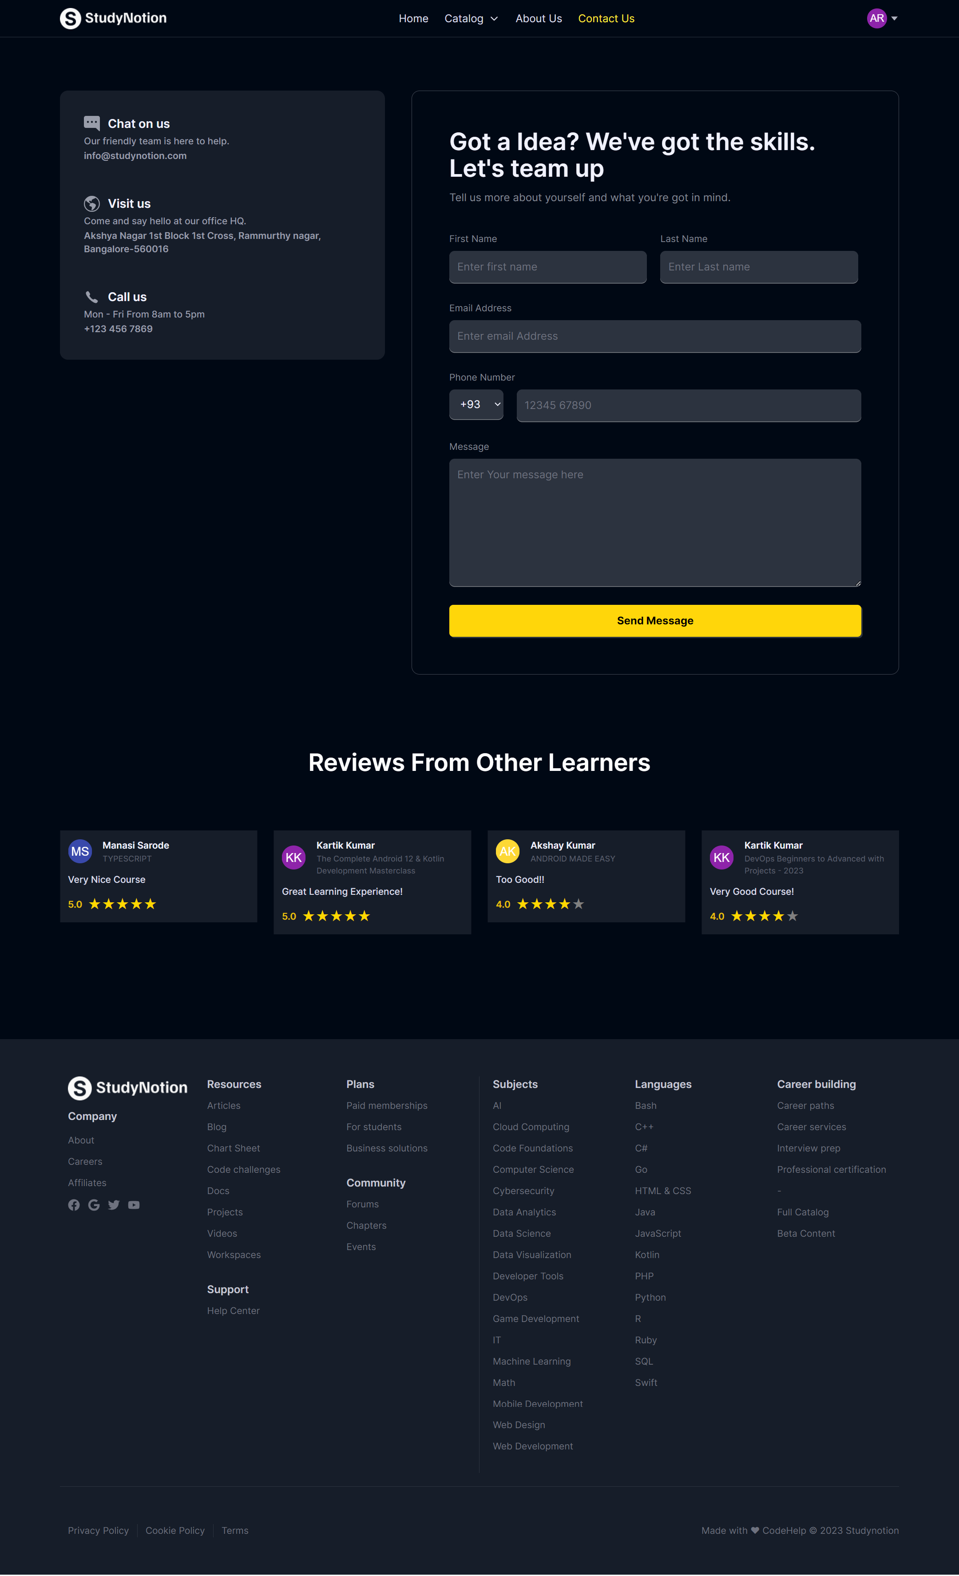

**3.15 Logout Section**

import { FiTrash2 } from "react-icons/fi"

import { useDispatch, useSelector } from "react-redux"

import { useNavigate } from "react-router-dom"

import { deleteProfile } from "../../../../services/operations/SettingsAPI"

export default function DeleteAccount() {

  const { token } = useSelector((state) => state.auth)

  const dispatch = useDispatch()

  const navigate = useNavigate()

  async function handleDeleteAccount() {

    try {

      dispatch(deleteProfile(token, navigate))

    } catch (error) {

      console.log("ERROR MESSAGE - ", error.message)

    }

  }

  return (

    <>

      <div className="my-10 flex flex-row gap-x-5 rounded-md border-[1px] border-pink-700 bg-pink-900 p-8 px-12">

        <div className="flex aspect-square h-14 w-14 items-center justify-center rounded-full bg-pink-700">

          <FiTrash2 className="text-3xl text-pink-200" />

        </div>

        <div className="flex flex-col space-y-2">

          <h2 className="text-lg font-semibold text-richblack-5">

            Delete Account

          </h2>

          <div className="w-3/5 text-pink-25">

            <p>Would you like to delete account?</p>

            <p>

              This account may contain Paid Courses. Deleting your account is

              permanent and will remove all the contain associated with it.

            </p>

          </div>

          <button

            type="button"

            className="w-fit cursor-pointer italic text-pink-300"

            onClick={handleDeleteAccount}

          >

            I want to delete my account.

          </button>

        </div>

      </div>

    </>

  )

}

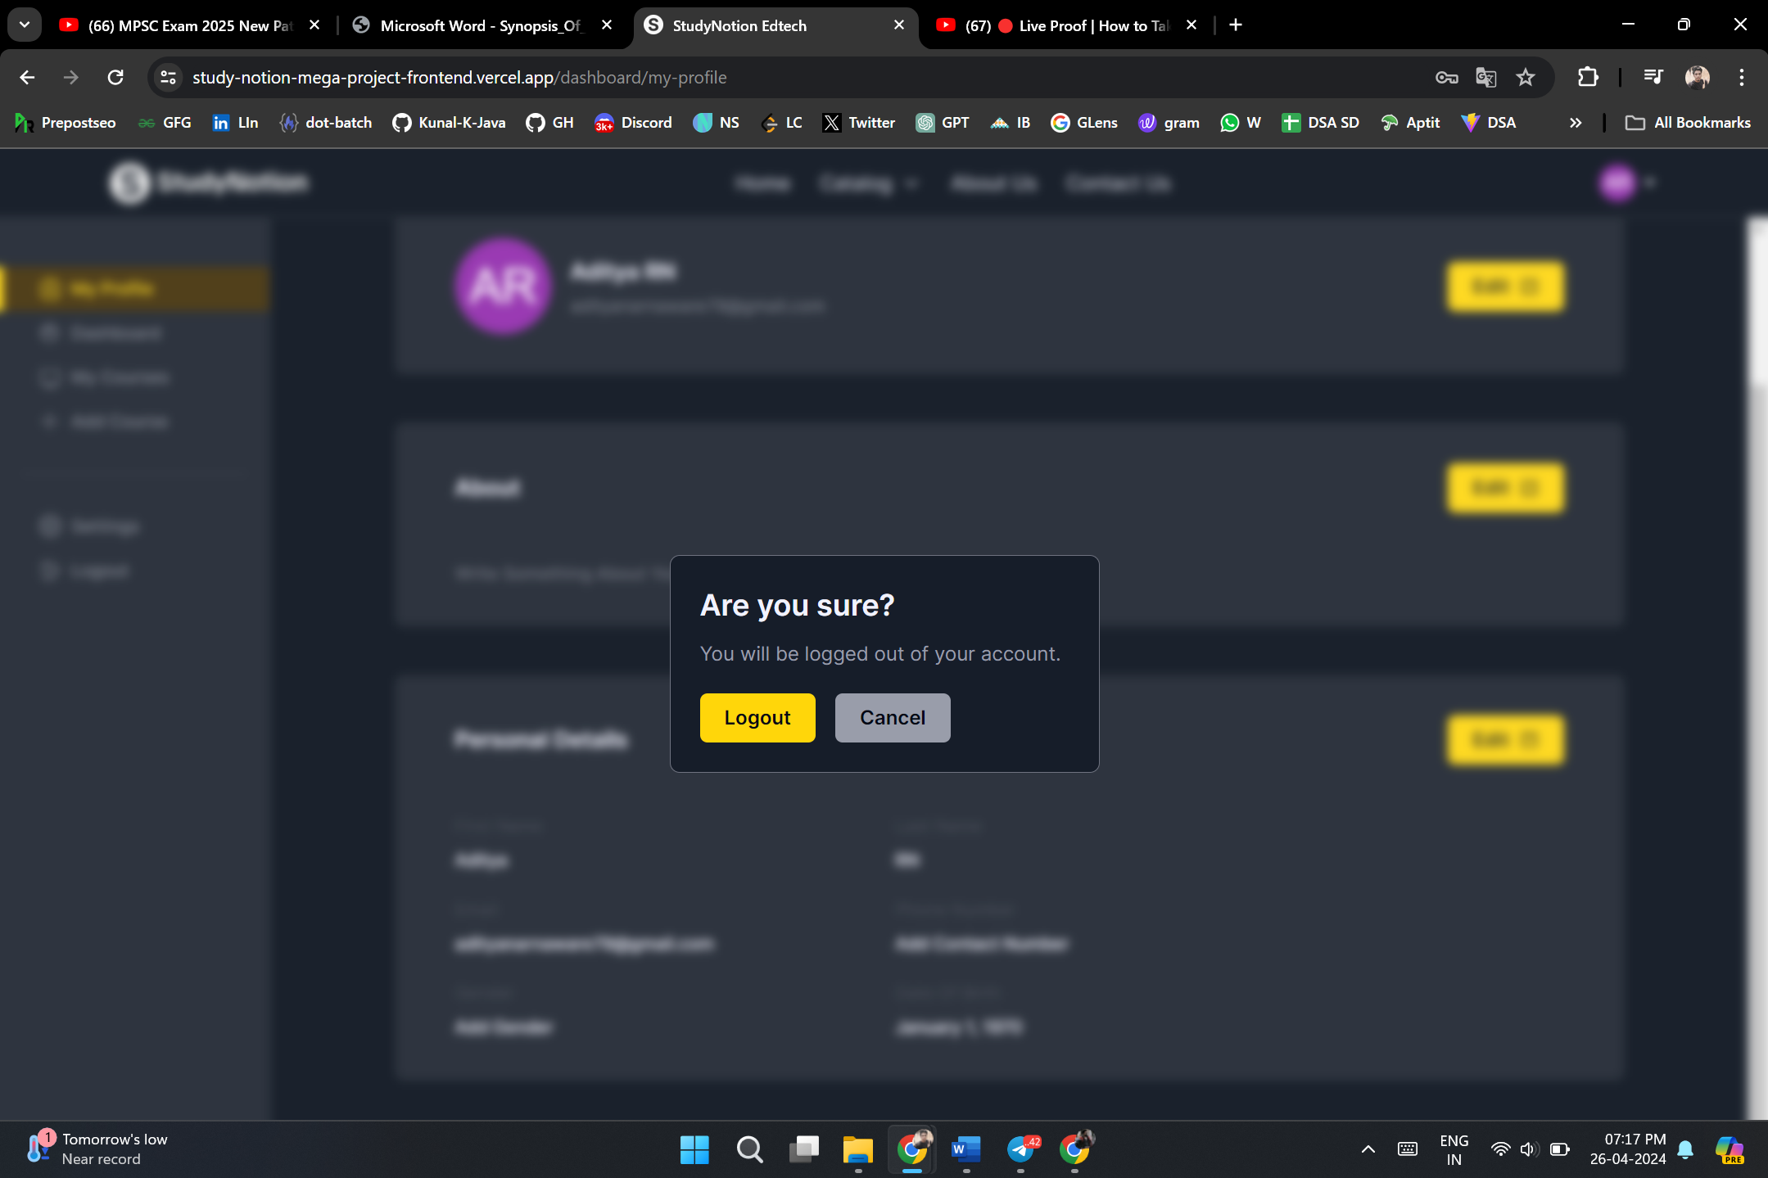

**5.2 Model Output**

The output of the recommender system, including personalized recommendations, is discussed and analyzed.

**5.3 Summary**

The chapter summarizes the key findings from the implementation and evaluation processes, highlighting the effectiveness of the Study Notion Portal Website in providing personalized recommendations.

**CHAPTER 6**

**CONCLUSIONS AND RECOMMENDATIONS**

**6.1 Introduction**

This final chapter provides a comprehensive conclusion to the research, discussing contributions, future work, and recommendations.

**6.2 Discussion and Conclusion**

The findings of the study are discussed in detail, emphasizing the impact of the Study Notion Portal Website and the recommender system on user experience and learning outcomes.

**6.3 Contributions**

The chapter highlights the contributions of the research, including advancements in online courses systems, the integration of recommender systems, and the enhancement of user engagement.

**6.4 Future Work**

Suggestions for future research are provided, addressing potential areas for improvement, expansion, and innovation in the field of online courses platforms.

**6.5 Recommendations**

Concluding recommendations are presented, providing guidance for educational institutions and developers seeking to implement similar systems.

This detailed report provides a comprehensive overview of the research methodology, implementation, results, and conclusions related to the development of the Study Notion Portal Website with an integrated recommender system.

**REFRENCES**

Subhashini, S., & Padmavathi, G. (2016). Online course system. International Journal of Advanced Research in Computer Science and Software Engineering, 6(9), 12-17.

Amin, A., & Sharma, R. (2019). Design and development of secure online course system. International Journal of Computer Applications, 180(7), 1-5.

EDUCAUSE. (n.d.). Online Assessment. eLearning Industry. (n.d.).

E-Learning Solutions for Online courses.

Dehnavi, M. M., & Jalili, S. (2016). Online courses system: A case study of designing a web-based online study portal system. In 2016 4th International Conference on Cyber Intelligence and Security (CIS) (pp. 91-96). IEEE.   
  
<https://www.google.com/>

<https://youtube.com>/

<https://developer.mozilla.org/>

<https://www.geeksforgeeks.org/>

<https://www.javatpoint.com/>

<https://www.w3schools.com/>

<https://stackoverflow.com/>

<https://www.wikipedia.org/>

<https://mdn.org/>

<https://www.postman.com/>

<https://www.mongodb.com/>

<https://vercel.com/>